|  |  |  |  |
| --- | --- | --- | --- |
|  | Report On E-Auction And E-Procurement | |  |
|  | |
| 04/12/2023 | |
|  | ADD COMPANY NAME HERE | |  |
| Veer Patel (Data Analyst Intern) Suyog Ubhare (Data Analyst Intern) Aishwarya Patil (Data Analyst Intern) |  |  |
|  | |  |

# E-Auction

What is E-Auction?  
An E-Auction is a transaction between sellers (the auctioneers) and bidders (suppliers in the business-to-business scenarios) in an electronic marketplace.

It can occur business-to-business, business-to-consumer, or consumer-to-consumer, and allows suppliers to bid online against each other for contracts against a published specification.

## Types of E-Auction Software

Before diving in, it's important to understand the different types of e-auction software available:

* General-purpose platforms: These platforms cater to a wide range of items and industries, from collectibles and antiques to cars and real estate. Examples include eBay, HiBid, and AuctionAnything.
* Industry-specific platforms: These platforms focus on specific industries, offering features and functionalities tailored to their unique needs. Examples include Procol for procurement auctions, Bidsketch for art auctions, and GovDeals for government surplus auctions.
* Reverse auction platforms: Here, the seller sets a starting price and buyers bid downwards, competing for the lowest price. This format is popular for sourcing goods and services. Examples include ScoutRFP and Icertis.

## Key Features of E-Auction Software

* Item listing and management: Create detailed descriptions, upload photos and videos, set starting bids and reserve prices.
* Bidding and notifications: Bid in real-time, receive alerts when outbid, set automatic bidding strategies.
* Security and fraud prevention: Secure payment processing, user verification, bidder reputation tracking.
* Reporting and analytics: Track auction performance, analyze bidder behavior, generate detailed reports.
* Customization and integrations: Tailor the platform to your specific needs, integrate with other business software.

## Benefits of E-Auction Software

* Reach a wider audience: Attract potential buyers from all over the globe, increasing competition and potentially driving higher prices.
* Reduce costs and overhead: Eliminate physical auction venue expenses, streamline processes, and save valuable time.
* Transparency and fairness: Real-time bidding and clear visibility of all bids ensure a level playing field for all participants.
* Data-driven insights: Gain valuable insights into market trends, buyer behavior, and auction performance for better decision-making.
* Improved efficiency: Automate tasks, manage contracts and invoices online, simplify post-auction logistics.

E-Bay:  
Let's dive into the world of eBay, one of the most popular and versatile e-auction platforms. With millions of users and a vast array of items, eBay offers something for everyone.  
  
**Home-Page E-bay:**  
eBay has continued enhancing it to make sure it truly is specific to the person using it—not just the items alone, but also how these items are displayed and how users interact with the page. The latest updates to the homepage bring a sweep of accessibility improvements to the design, making the page easier to use for people with or without disabilities and creating more convenience for users overall.  
 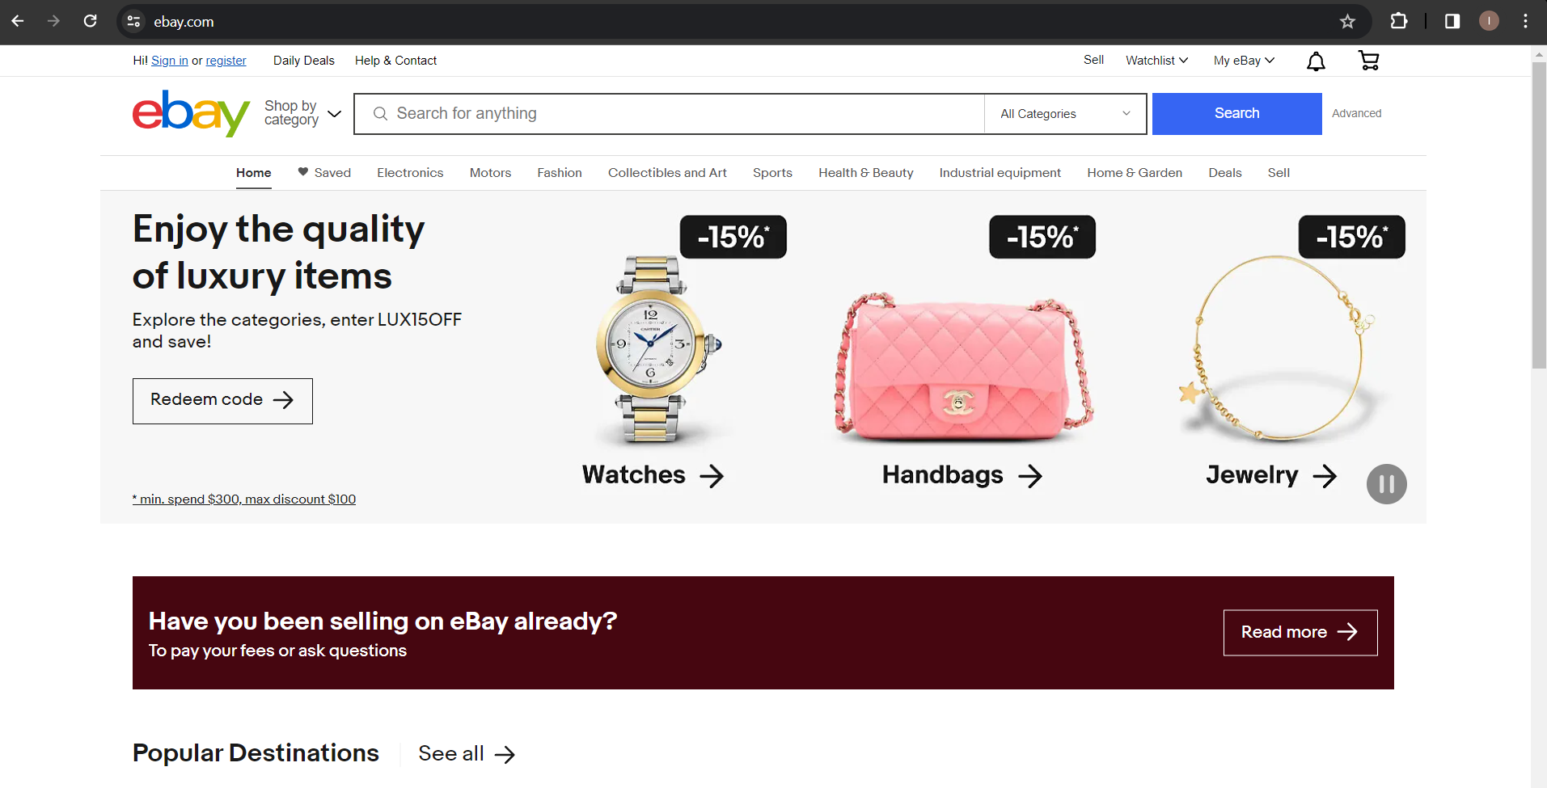

E-bay Home Page

**Item listing:**   
Steps to list the items is given below:

**Step 1**. Start creating a listing  
 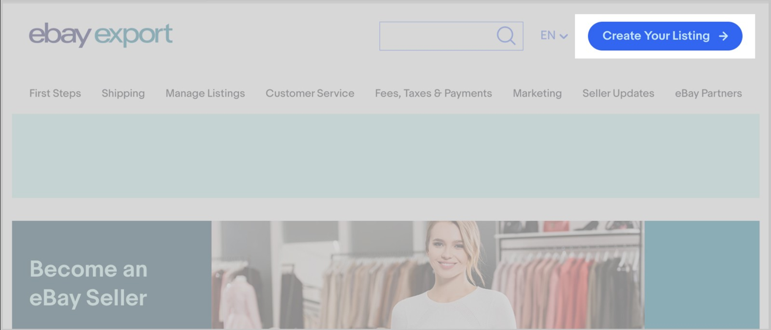

**Step 2**. Tell eBay what you are selling

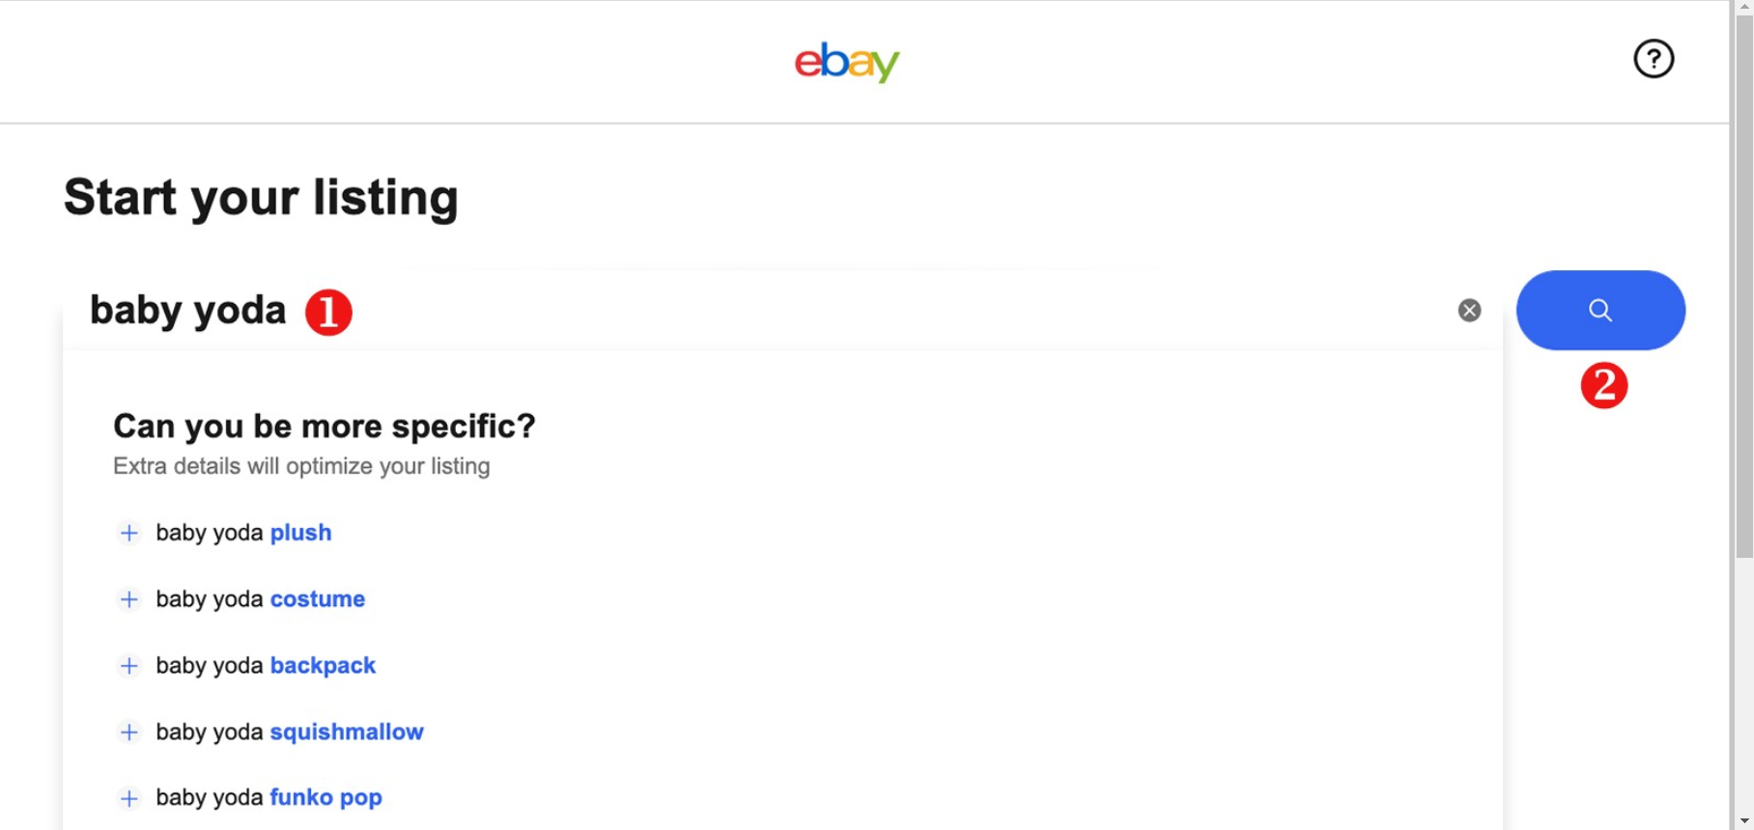

**Step 3**. Add photos and a video

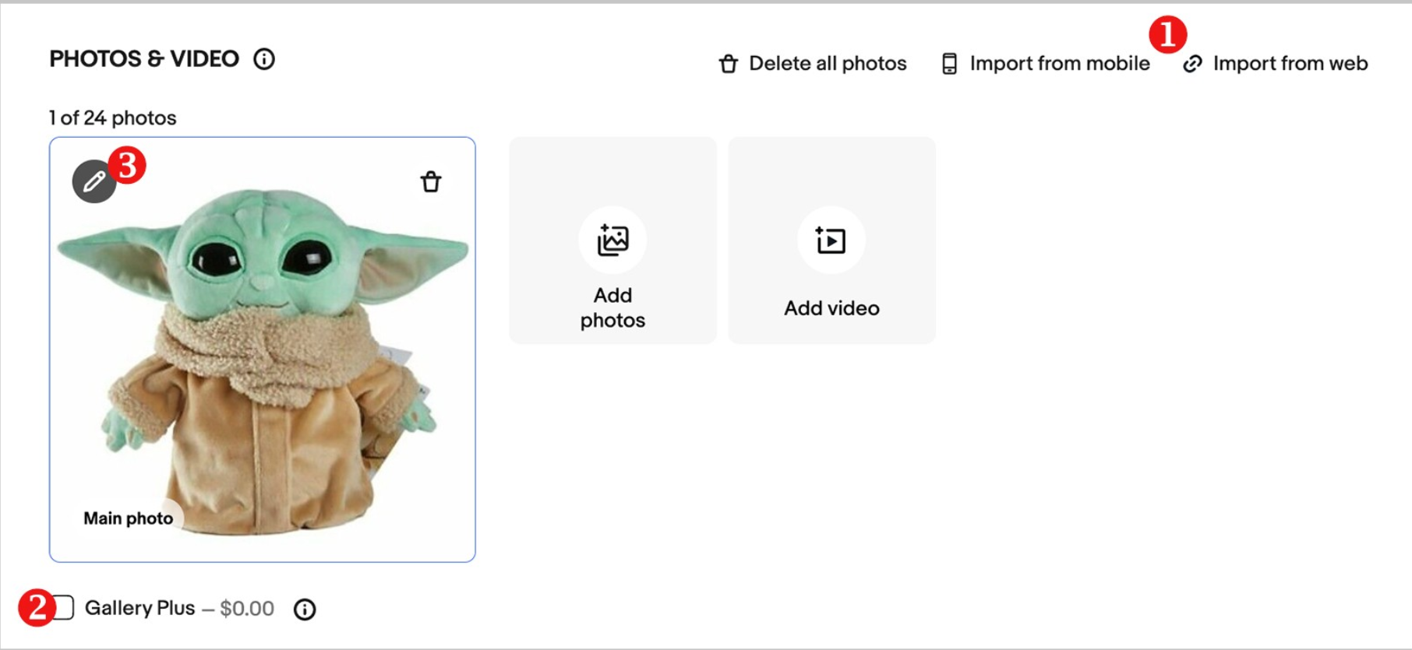

**Step 4**. Provide titles and specify the category

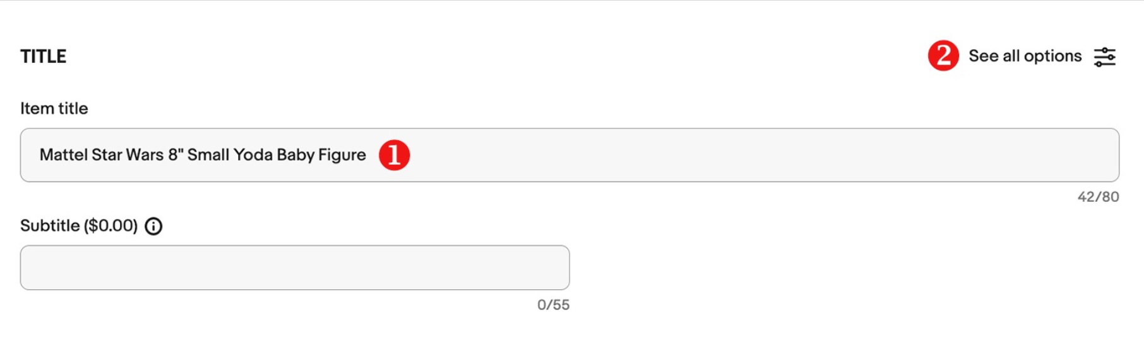

**Step 5.** Add item specifics and variations

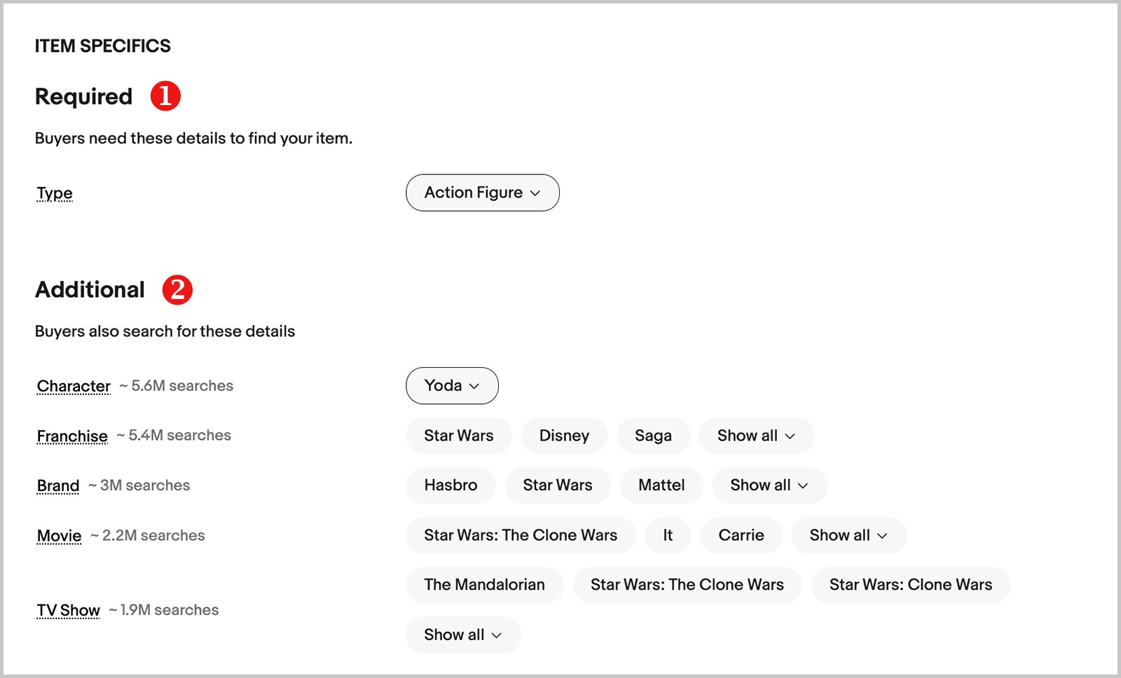

**Step 6.** Describe your item and specify the condition

Provide a condition (1) for your item such as New, Used, or Refurbished.

If it is not new, give a comprehensive Condition description (2). Let the buyer know what makes your item unique, including any interesting features or flaws.

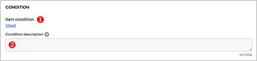

Enter an informative item description into the correspondent text field. Make sure that it is clear and concise, but be detailed enough so that there won’t be any confusion.

* Buyers trust simple, consistent formatting
* It's recommended sticking to one typeface with a black, 14pt font
* To save time, use templates
* HTML content won't be displayed on the first page of your View Item page on mobile. Since mobile buyers account for over 80% of traffic.

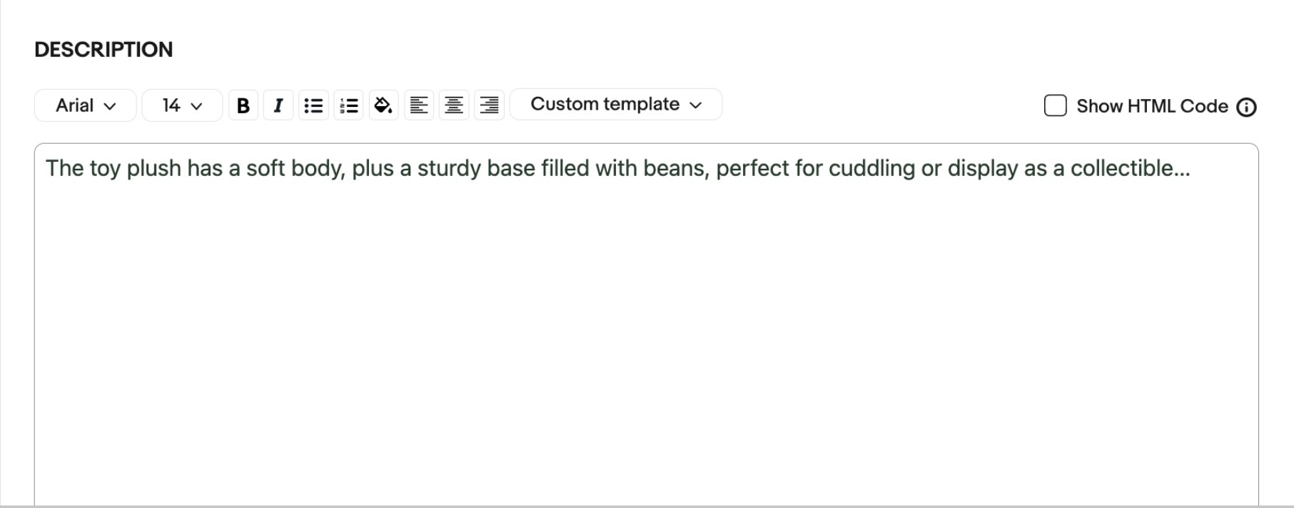

**Step 7**. Choose the format and price your item

By default, the listing has a fixed price format. Set your **Price**, whether you want to allow **Offers**, set your **Quantity**, and a **Scheduled start time**. You can click **Edit** (1) to change the format or make other adjustments.

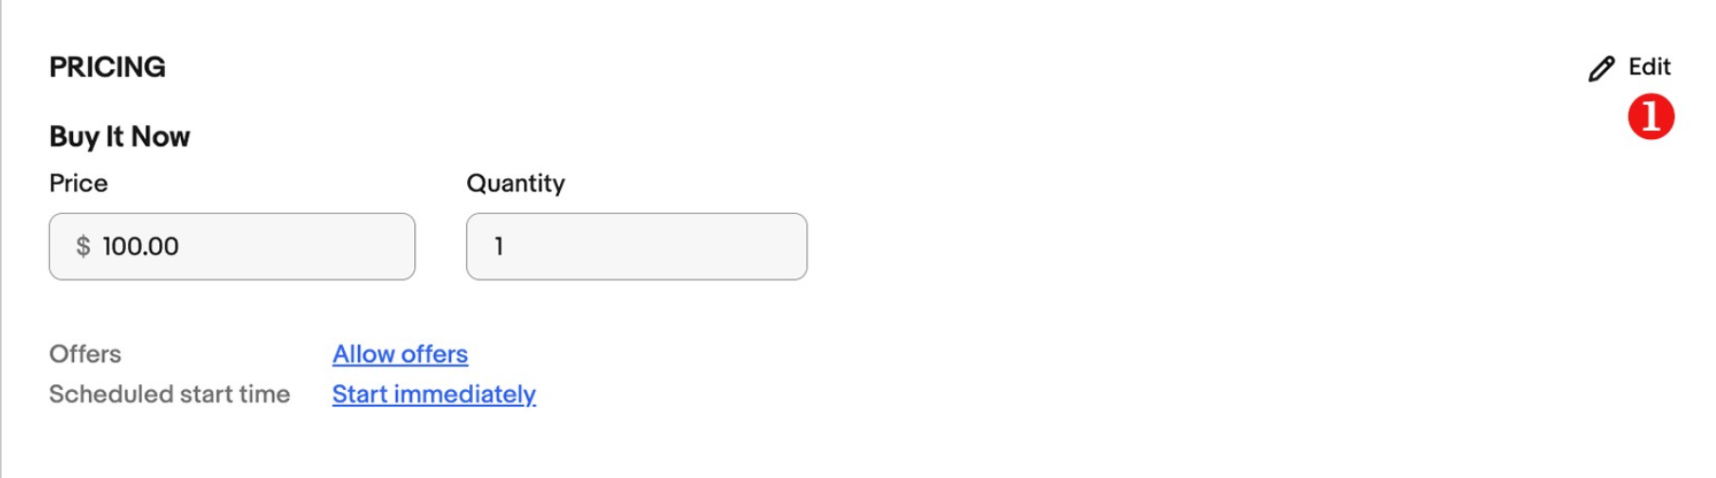

For auction listings set your **Price**, an **Auction duration**, whether you want to allow **Offers**, or add a **Reserve price**, a **Scheduled start time** or a **Buy It Now** option.

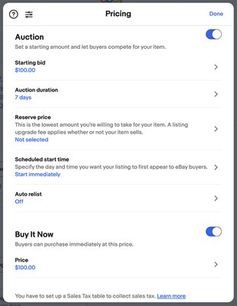

**Step 8**. Set up shipping details

In the shipping section, you need to specify your shipping terms and the regions you ship your item to. You can go with recommended delivery options (if available) or select your own. You can also make this process more efficient by creating

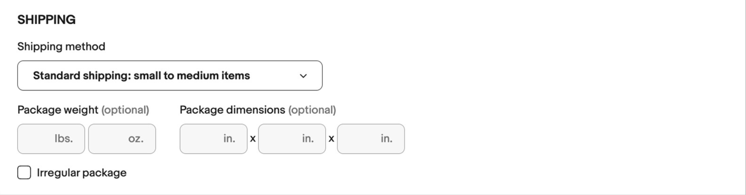

If you list your item on ebay.com, please remember that Domestic shipping (1) refers to the territory of the United States. To add shipment to other countries, enable the slider next to **Add additional international service** (2) in the International shipping section. If the item you’re selling is large or difficult to ship, offer local pickup (3) and the buyer can collect it in person.

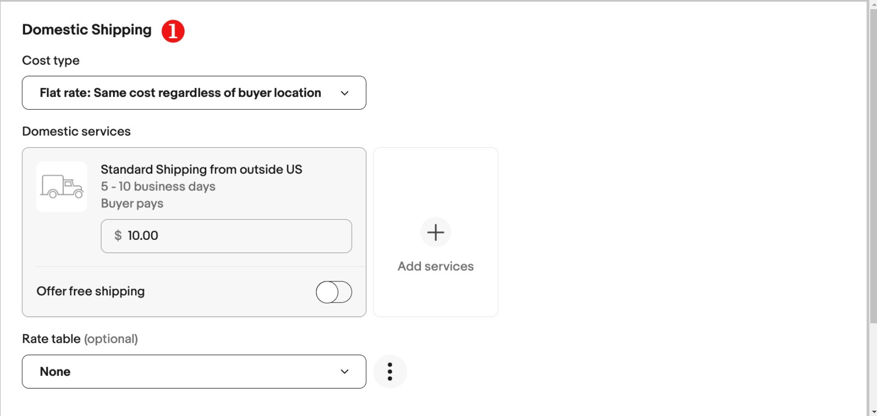

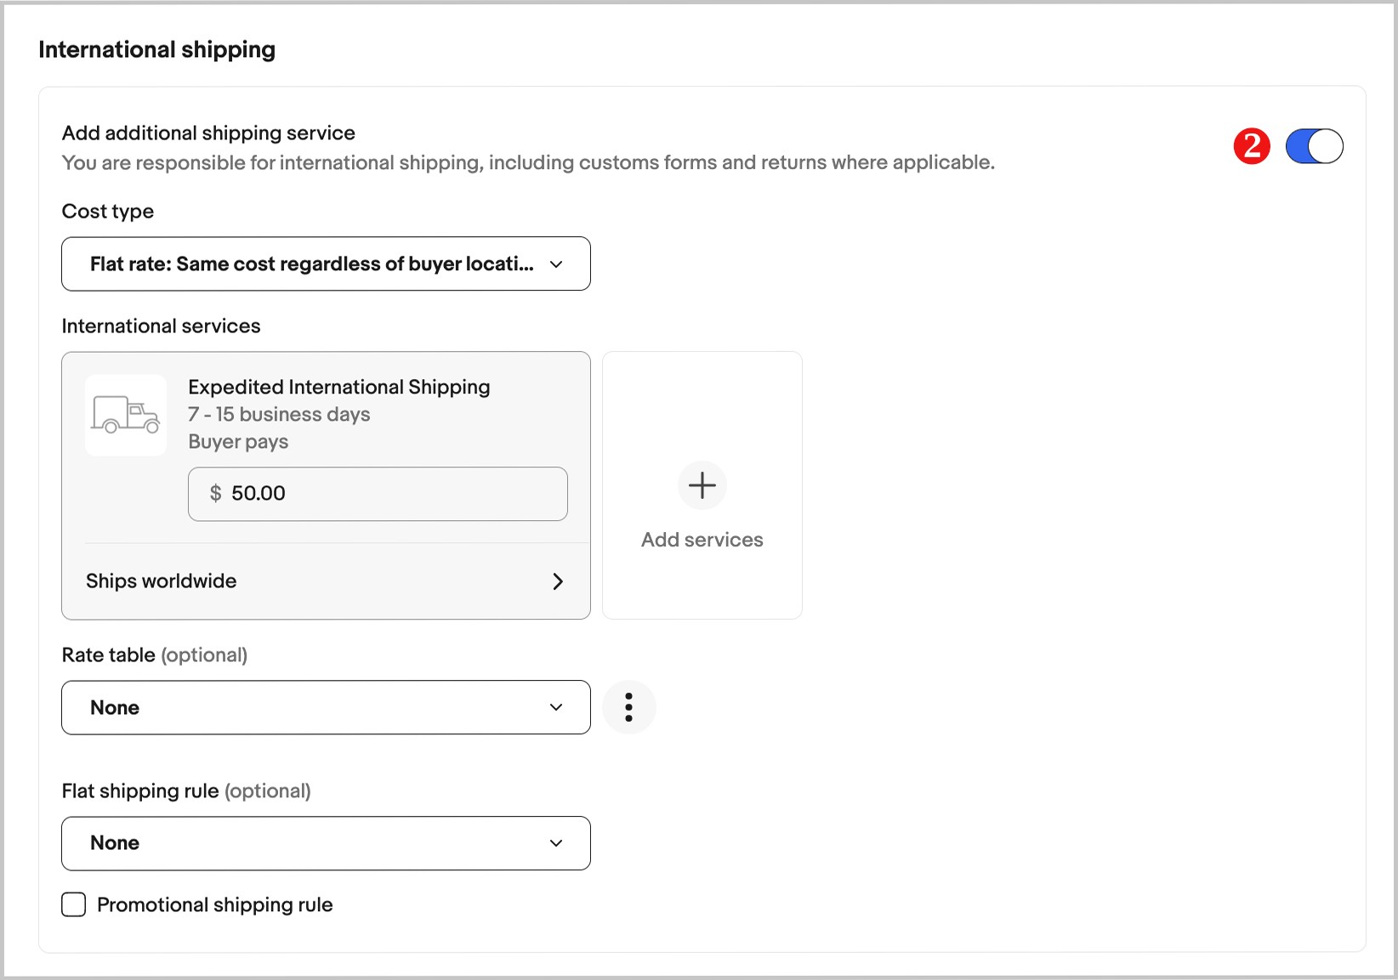

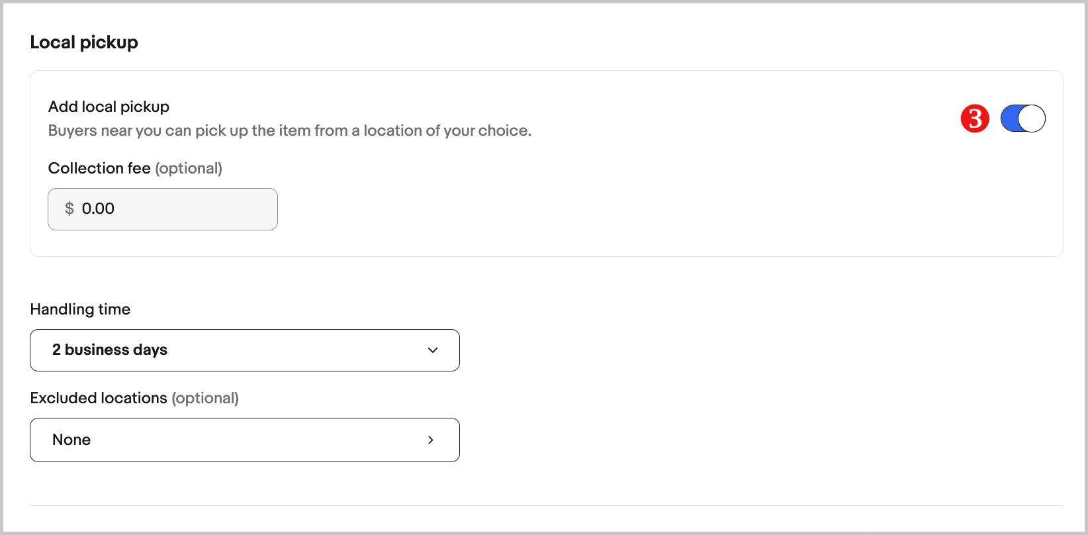

**Step 9**. Reach more buyers

Improve your chances of selling with Promoted Listings (1) and Volume Pricing (2).

Promoted Listings Standard campaigns help your listings stand out among lots of similar items. You only pay when your item sells.

Volume Pricing is a discount that your buyers get for buying more than one item at a time. This option is only available on fixed price listings.

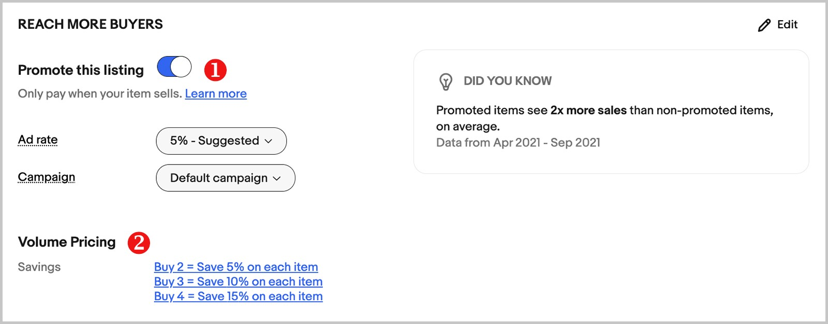

**Step 10**. Specify your selling preferences

Choose a payment method (1), item location (2) and a returns policy (3). Click on any active link to change it, or select **Edit** (4) to adjust all settings.

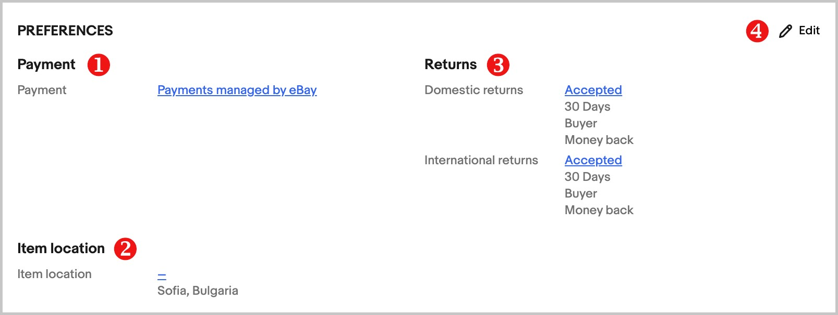

**Step 11**. Set up charity option

If you want to support a good cause, eBay allows you to set up automatic donations of a certain percentage of your item’s final sale price. You will receive a donation receipt and discount for your fees of an equal percentage.

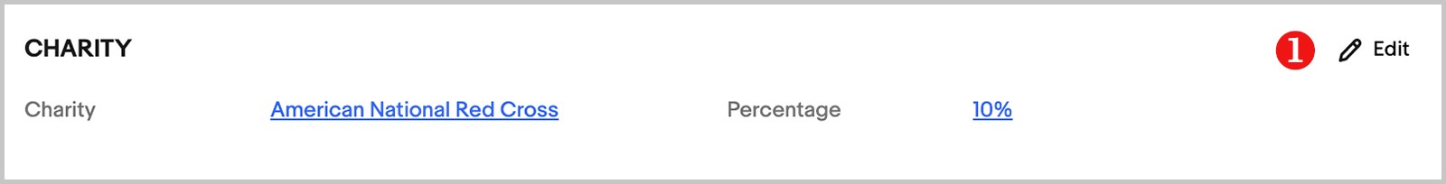

**Step 12**. Check and list your item

Your listing is almost ready. If you see a blue "i" symbol above any section, it means that section requires more information before you can list.

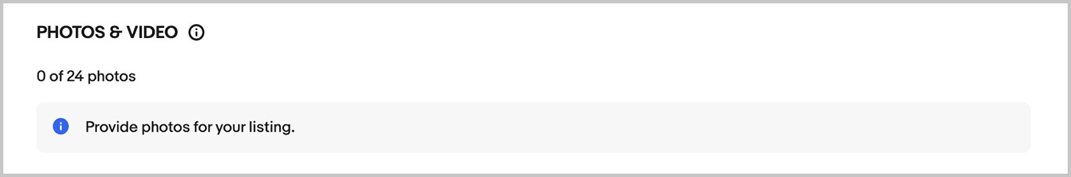

If everything is OK, select **List it** (2). If you are not quite sure, edit it again or click **Save for later** (3). It will be saved as a draft, which you can revise and list later.

At the bottom of the page, you will see the total amount of fees that will apply (4). If you see the words **List it for free**, it means that there are no fees for listing this item, but a final value fee will apply when you sell it.

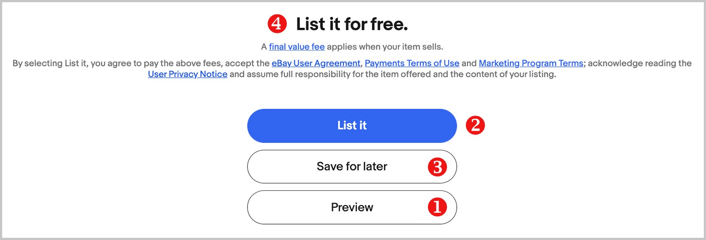

## eBay Auction Flowchart: Buyer and Seller Journeys

* Buyer Journey:
* Start: User opens eBay and browses categories, searches for items, or checks watchlist.
* Find item: User identifies a desired item and views its details (photos, description, bid history, seller feedback).
* Decision point: User chooses to:
  + Watchlist: Add the item to their watchlist for later.
  + Bid: Enter a bid amount or use "Max bid" option.
  + Buy It Now: Purchase the item immediately (avoids auction process).
* Bidding (optional): User tracks bids, receives outbid notifications, and adjusts bids if needed.
* Auction ends: User wins the auction or gets notified if outbid.
* Checkout: User pays the seller through eBay and receives shipping information.
* Receive item: User inspects the item and leaves feedback for the seller. 

Seller Journey:

* Start: Seller opens eBay and selects "Sell".
* Listing creation: Seller enters item details (title, description, photos, condition, starting bid, reserve price, shipping options, payment methods).
* Listing published: Seller reviews and publishes the listing.
* Bidding starts: Potential buyers view the listing and start bidding.
* Manage bids: Seller answers buyer questions, monitors bids, and adjusts reserve price if needed.
* Auction ends: Seller wins the auction (if reserve price met) or relists the item.
* Payment received: Seller receives payment from eBay and ships the item to the buyer.
* Track shipment: Seller provides tracking information and confirms delivery.
* Receive feedback: Seller receives feedback from the buyer and improves future listings based on feedback.

Flowchart For Buyer and seller

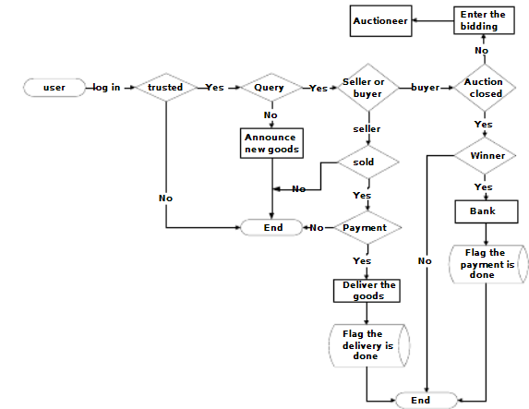

## E-Auction Software: Data Fields with Descriptions

Let's dive into the heart of the e-auction software - the data fields that power the entire experience! Here's a breakdown of key fields with their descriptions, focusing on eBay as our example:

Item-related fields:

* Item title: Concise and descriptive title summarizing the item (e.g., "Antique Silver Pocket Watch").
* Item description: Detailed information about the item, including condition, specifications, and any flaws.
* Category and subcategories: Classify the item for easier search and browsing (e.g., Jewelry > Watches > Pocket Watches).
* Starting bid: Minimum amount buyers can start bidding.
* Reserve price (optional): Hidden minimum price the seller needs to reach for a successful auction.
* Condition: Brand new, used, or for parts (affects perceived value).
* Brand and manufacturer: If applicable, identifies the brand and maker of the item.
* Photos and videos: Visual representations of the item from various angles and functionalities.

Bid-related fields:

* Bid amount: Specific amount a buyer offers for the item.
* Maximum bid (optional): Buyer sets their highest limit, and the platform automatically bids on their behalf within that range.
* Bid history: List of all bids placed on the item, including timestamps and bidder usernames (partially anonymized).
* Current highest bid: Identifies the leading bidder and their current offer.
* Time remaining: Countdown until the auction ends, creating a sense of urgency.

Seller-related fields:

* Seller username: Unique identifier for the seller on the platform.
* Seller feedback score and percentage: Indicates the seller's past performance and trustworthiness based on buyer reviews.
* Location: City and country where the seller are based (affects shipping costs).
* Return policy: Seller's policy on returns and refunds for buyers.
* Payment options accepted: Lists the payment methods the seller allows (e.g., PayPal, credit cards).

Shipping-related fields:

* Shipping cost: Price buyers pay for the item to be delivered to their address.
* Shipping service and estimated delivery time: Identifies how the item will be shipped and how long it might take to arrive.
* International shipping: Whether the seller offers shipping outside their country and any additional costs.

Additional fields:

* Watchlist count: Number of users who have added the item to their watchlist, indicating potential interest.
* Unique item ID: Identifies the item within the platform's database for tracking and reference.
* Keywords: Seller-defined words that help buyers discover the item through searches.
* Special attributes: Fields specific to the item category, like material, size, or edition number.

## eBay: How it works

Let's zoom in on the inner workings of eBay, beyond the surface of browsing and bidding. For Buyers:

1. Account Creation & Browsing:

* You create a free account and verify your email.
* Browse millions of items by category, keyword search, or filters (price, condition, location).
* Save favorite searches and get notified of new listings matching your criteria.

2. Finding the Perfect Item:

* View detailed descriptions, high-quality photos, and seller information.
* Check the condition (new, used, for parts) and bid history.
* Compare prices and features across similar listings.

3. Bidding & Winning:

* Enter your maximum bid or manually bid against other buyers.
* Track your bids in real-time and receive notifications when outbid.
* Use "Buy It Now" to purchase an item instantly without bidding (available at seller's discretion).

4. Checkout & Payment:

* Securely pay the seller through eBay's system, often using PayPal or credit card.
* Choose your preferred shipping option and see estimated delivery times.
* Track your shipment with detailed information.

5. Receiving & Feedback:

* Upon receiving the item, inspect it to ensure it matches the description.
* Leave feedback for the seller, rating your experience with the transaction.
* Benefit from eBay's Money-Back Guarantee if the item isn't as described.

For Sellers:

1. Listing Your Treasures:

* Create detailed listings with clear titles, descriptions, and multiple high-quality photos.
* Set competitive starting bids, reserve prices (hidden minimum bid), and choose an auction or fixed-price format.
* Add shipping options and costs, specifying domestic and international availability.

2. Managing Bids & Sales:

* Monitor bids and respond to buyer inquiries.
* Accept or decline offers on Buy It Now items.
* Print shipping labels through eBay and track shipments.

3. Receiving Payment & Feedback:

* Once the auction ends, the highest bidder (or Buy It Now buyer) pays you securely through eBay.
* Leave feedback for the buyer after receiving payment.

eBay's Role:

* Acts as a trusted intermediary, facilitating secure transactions and communication.
* Ensures buyer protection through Money-Back Guarantee and dispute resolution mechanisms.
* Charges sellers' fees based on listing format, final sale price, and optional add-on services.

Additional Features:

* Watchlists: Save items you're interested in and track their prices.
* Collections: Organize items by theme or interest for easier browsing.
* Saved Searches: Get notified of new listings matching your specific criteria.
* Guaranteed Delivery: eBay promises item arrival by a certain date or your money back.
* Seller Hub: Sellers can access advanced tools for managing inventory, promotions, and analytics.

Beyond the Basics:

* Explore eBay's vast community forums for tips, discussions, and seller support.
* Participate in specialized communities focused on specific collecting areas.
* Discover unique and rare items through curated collections and special events.

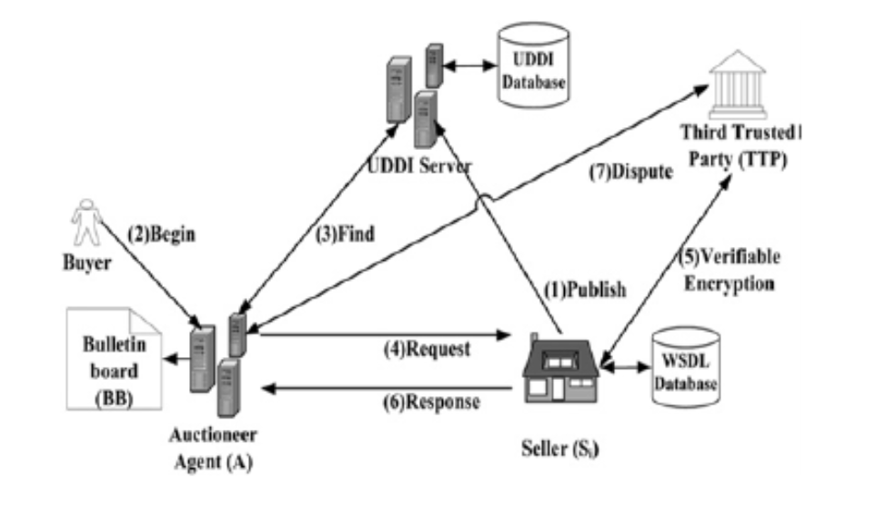  
 Model for e-auction for a web service

## Vendor Management System.

Vendor management software (VMS) is a software application that helps businesses manage their relationships with external suppliers or vendors. VMS can be used to automate and streamline many of the tasks involved in vendor management, such as:

* **Sourcing and onboarding new vendors**: VMS can help businesses find and qualify new vendors, and then onboard them into the organization.
* **Managing vendor contracts**: VMS can store and manage vendor contracts and track contract expirations and renewals.
* **Processing vendor invoices**: VMS can automate the processing of vendor invoices, and track payments to vendors.
* **Tracking vendor performance:** VMS can track vendor performance metrics, such as on-time delivery, quality of goods or services, and customer satisfaction.
* **Assessing vendor risk:** VMS can help businesses identify and assess vendor risks, such as financial stability, cybersecurity threats, and compliance issues.
* **Reporting on vendor data:** VMS can generate reports on vendor performance, risk, and compliance.

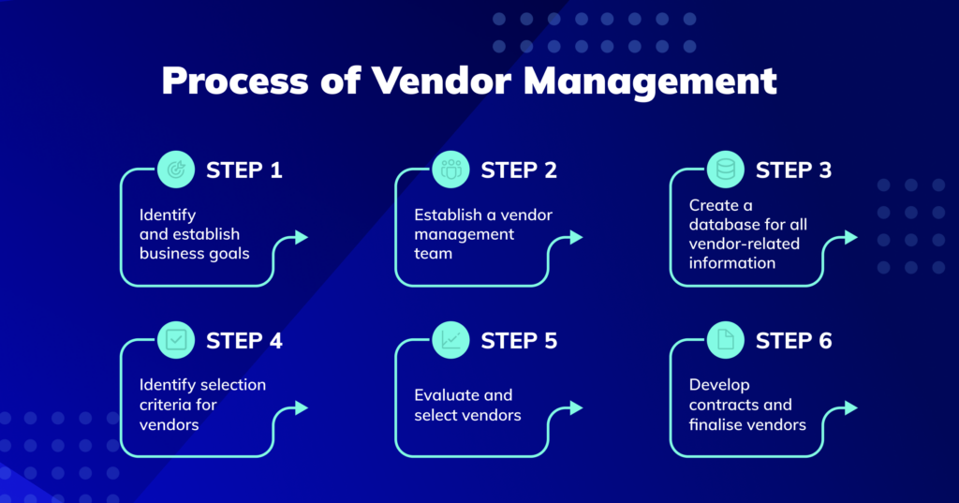

## Types of Reports:

* **Vendor performance reports:** These reports track vendor performance metrics, such as on-time delivery, quality of goods or services, and customer satisfaction.

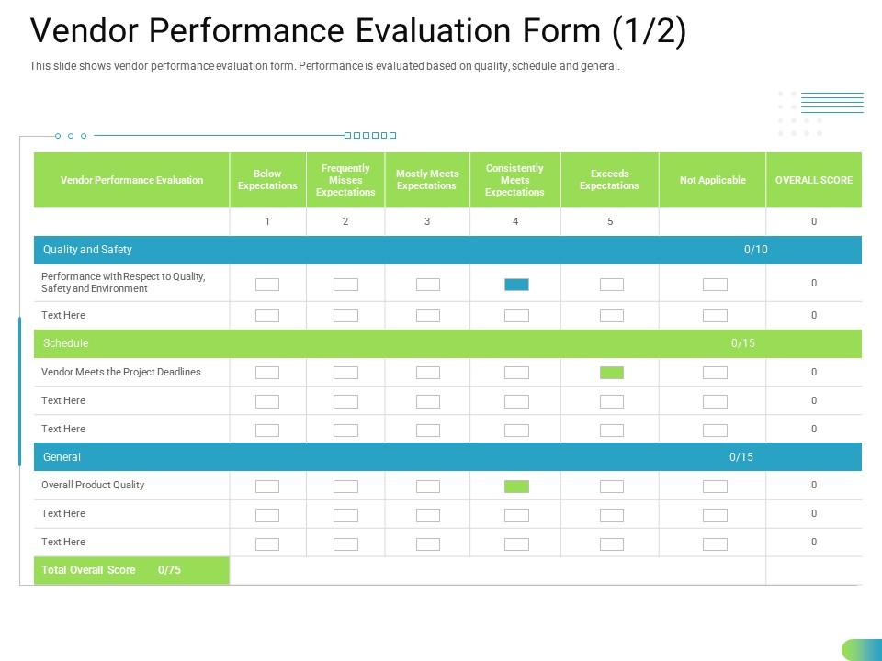

* **Vendor risk reports:** These reports identify and assess vendor risks, such as financial stability, cybersecurity threats, and compliance issues.

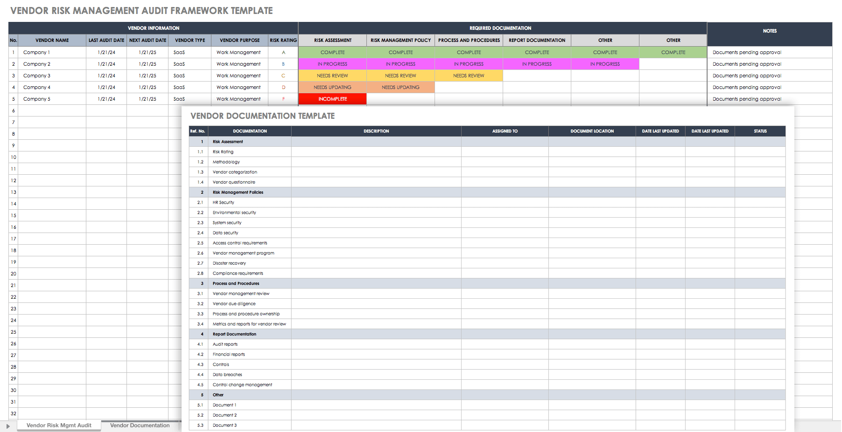

* **Vendor compliance reports:** These reports track vendor compliance with contracts, regulations, and internal policies.

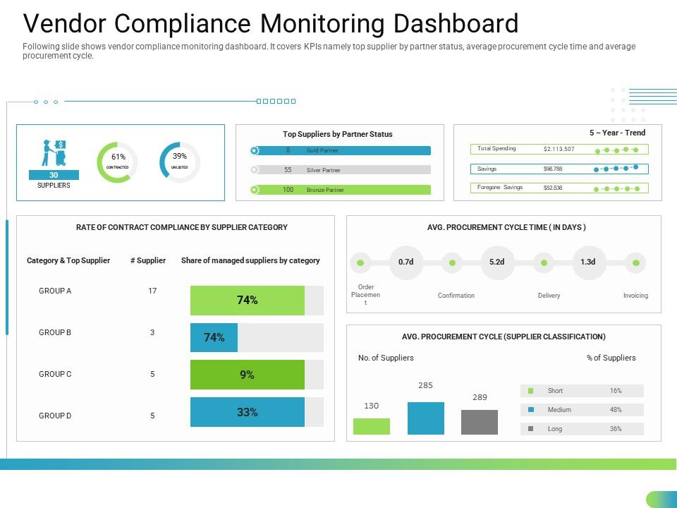

* **Vendor spend reports:** These reports track vendor spending by category, department, and vendor.

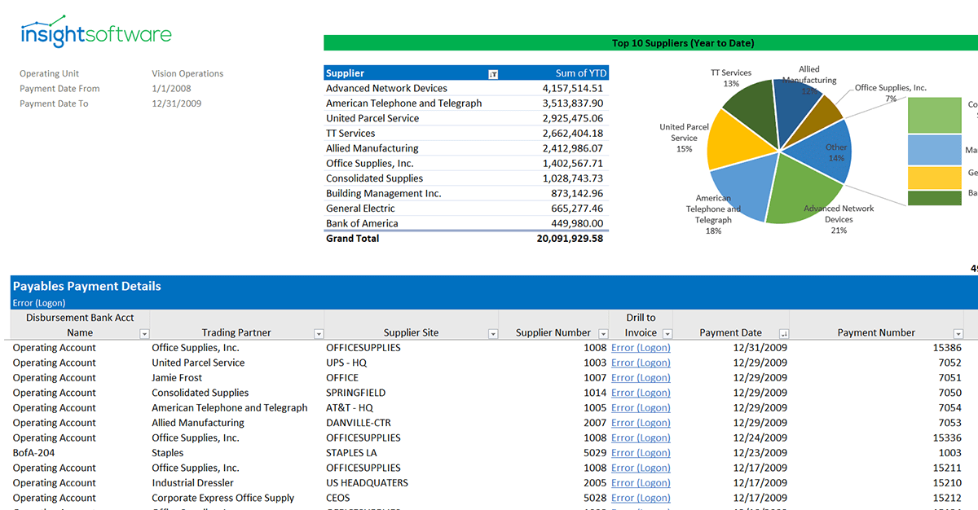

* **Vendor contact reports:** These reports provide contact information for key vendor personnel.

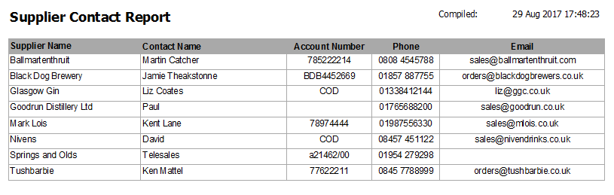

* **Vendor diversity reports:** These reports track the diversity of an organization's vendor base.

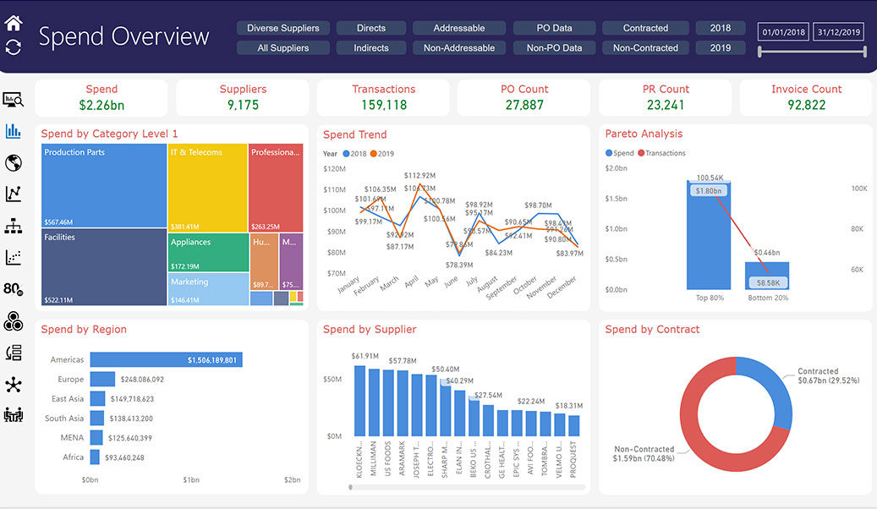

## Benefits of Reports:

* **Improved vendor performance:** By tracking vendor performance metrics, organizations can identify and address areas where vendors are falling short.
* **Reduced risk:** By identifying and assessing vendor risks, organizations can take steps to mitigate those risks.
* **Improved compliance:** By tracking vendor compliance, organizations can ensure that vendors are meeting their contractual obligations and regulatory requirements.
* **Cost savings:** By tracking vendor spend, organizations can identify opportunities to save money.
* **Improved relationships:** By having access to vendor contact information, organizations can build stronger relationships with their vendors.

## Customizable Reports:

Many VMS solutions allow users to customize reports to meet their specific needs. This means that organizations can create reports that track the metrics that are most important to them.

## Reporting Frequency:

Organizations can generate reports on a variety of frequencies, such as daily, weekly, monthly, or quarterly. The frequency of reporting will depend on the specific needs of the organization.

## Use Reports:

## Reports can be used to inform a variety of decision-making processes, such as:

* Vendor selection: Reports can be used to identify and select the best vendors for a particular project or initiative.
* Vendor negotiation: Reports can be used to negotiate better terms with vendors.
* Vendor performance management: Reports can be used to track vendor performance and identify areas for improvement.
* Risk management: Reports can be used to identify and assess vendor risks and develop mitigation strategies.
* Compliance management: Reports can be used to track vendor compliance and identify potential problems.

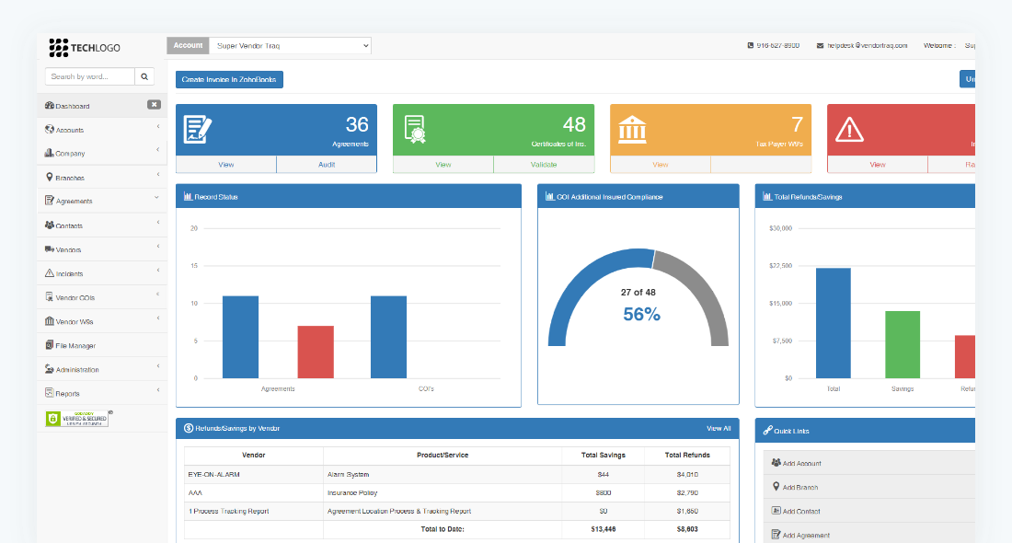

Dashboard

## Flowchart:

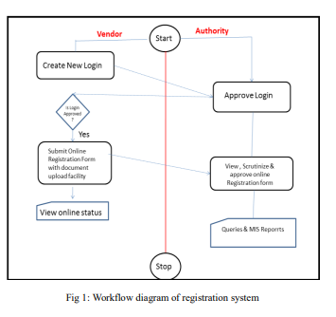

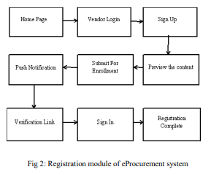

## Menu:

* **Vendor Management**
  + Vendor List
  + Vendor Profile
  + Vendor Risk Assessment
  + Vendor Performance
  + Vendor Compliance
  + Vendor Reports
* **Contract Management**
  + Contract List
  + Contract Creation
  + Contract Negotiation
  + Contract Approval
  + Contract Management
  + Contract Reports
* **Spend Management**
  + Spend Analysis
  + Purchase Order Management
  + Invoice Processing
  + Payment Management
  + Spend Reports

## Flow Of the Software:

1. **Vendor onboarding:** New vendors are added to the system and their information is entered, such as contact information, company details, and risk assessment.
2. **Contract management:** Contracts are created, negotiated, and approved. The system tracks the status of each contract and alerts users when contracts are expiring.
3. **Spend management:** Purchase orders are created, invoices are processed, and payments are made. The system tracks vendor spend and provides reports on spending patterns.
4. **Reporting:** Reports are generated on vendor performance, risk, compliance, and spend. These reports can be used to identify trends, make informed decisions, and improve vendor management.

## 

## Data Fields with Description:

* **Vendor name:** The name of the vendor.
* **Vendor contact information:** The vendor's contact information, such as phone number, email address, and website.
* **Vendor company details:** The vendor's company details, such as address, business type, and industry.
* **Vendor risk assessment:** The vendor's risk assessment, which includes factors such as financial stability, cybersecurity threats, and compliance

## How it Works:

VMS solutions come in various flavors, but their core functionality revolves around streamlining and optimizing vendor relationships throughout their entire lifecycle. Here's how it generally works:

**Onboarding & Profile Management:**

* Vendor Invitation: Easily invite potential vendors through email or online portals.
* Information Gathering: Capture vendor details, certifications, and performance history.
* Categorization & Risk Assessment: Classify vendors based on industry, services offered, and potential risks (financial, cybersecurity, legal).
* Approval Workflow: Define approval stages with assigned roles and automated notifications.

**Procurement & Contract Management:**

* Request for Quotation (RFQ) Creation: Generate standardized RFQs for specific needs, inviting bids from qualified vendors.
* Bid Submission & Evaluation: Vendors submit proposals electronically, and the system facilitates comparison and scoring based on predefined criteria.
* Contract Negotiation & Collaboration: Securely negotiate terms, pricing, and service levels within the platform itself.
* Contract Repository & Tracking: Store all contracts electronically, track key dates (renewal, expiration), and automate reminders for critical milestones.

**Performance Monitoring & Reporting:**

* Order Management & Tracking: Track purchase orders, deliveries, and invoices in real-time.
* Performance Metrics: Monitor key performance indicators (KPIs) like on-time delivery, quality, and cost per unit.
* Automated Alerts & Escalations: Set up alerts for performance deviations, contract breaches, or potential risks.
* Vendor Scorecards & Dashboards: Generate comprehensive reports and dashboards to analyze vendor performance, identify top performers, and areas for improvement.

**Payment & Compliance Management:**

* Three-Way Matching: Automate invoice matching against purchase orders and receiving reports for accuracy and faster processing.
* Payment Approvals & Workflow: Route invoices for approval based on pre-defined rules and roles.
* Flexible Payment Options: Offer vendors various payment methods like ACH, wire transfer, or virtual cards.
* Compliance Monitoring: Ensure adherence to legal and regulatory requirements through automated checks and reporting.

**Examples of Vendor Management Sites:**

There are many different vendor management sites available, each with its own strengths and weaknesses. Some of the most popular vendor management sites include:

* Coupa
* SAP Ariba
* Oracle Fusion Cloud Procurement
* JAGGAER
* Zycus

Ariba:

Ariba is a cloud-based business-to-business (B2B) commerce platform that helps businesses connect, collaborate, and transact with each other. It is a suite of applications that enables businesses to streamline their procurement, sourcing, and supply chain processes. Here are some of the key benefits of using Ariba:

* Increased efficiency: Ariba can help businesses automate many of their manual procurement processes, such as sourcing, requisitioning, and invoicing. This can free employees to focus on more strategic tasks.
* Reduced costs: Ariba can help businesses save money on their procurement spend by helping them find better deals from suppliers. It can also help businesses negotiate better contracts with suppliers.
* Improved visibility: Ariba provides businesses with real-time visibility into their supply chains, which can help them identify and mitigate risks.
* Enhanced collaboration: Ariba can help businesses collaborate more effectively with their suppliers, which can lead to improved innovation and product development.

Here are some of the key features of Ariba:

* Sourcing: Ariba Sourcing helps businesses find and evaluate suppliers.
* Contracts: Ariba Contracts helps businesses create and manage contracts with suppliers.
* Supplier Lifecycle and Performance: Ariba Supplier Lifecycle and Performance helps businesses manage their supplier relationships.
* Invoicing: Ariba Invoicing helps businesses automate their invoicing process.
* Network: Ariba Network is a global network of businesses that use Ariba to connect and transact with each other.

Ariba is used by businesses of all sizes, from small businesses to large enterprises. It is a popular choice for businesses in a variety of industries, including manufacturing, retail, and healthcare.

Here are some of the largest companies that use Ariba:

* Coca-Cola
* PepsiCo
* General Motors
* Ford Motor Company
* Boeing
* Walmart
* Target
* Home Depot
* Lowe's
* Amazon

# SAP Ariba - Account Configuration

In SAP Ariba, you can access and configure new accounts, set email notifications, electronic order and invoice routing and other account related configuration for new suppliers.

* Go to [https://supplier.ariba.com.](https://supplier.ariba.com/)
* To login to your account, enter username and password.

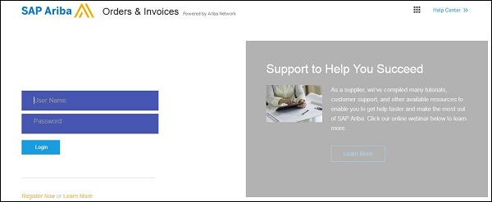

* To configure account access and configuration, you need to navigate to Company Settings tab.
* Navigate to Company Profile tab to update company profile information.

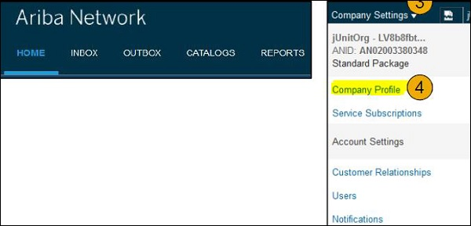

From the company profile menu, you can update the below information −

* Basic company profile
* Business Details
* Marketing
* Company Contacts
* Certification details
* Additional documents

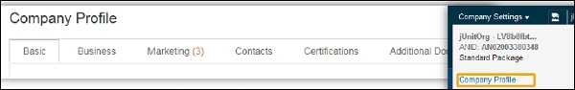

## Creating Notifications

SAP Ariba allows you to set notifications and access network notification. You can choose on the email notifications you want to receive and you can also enter the email address where you want these notifications to be sent.

To set notifications,go to Notification tab → Network

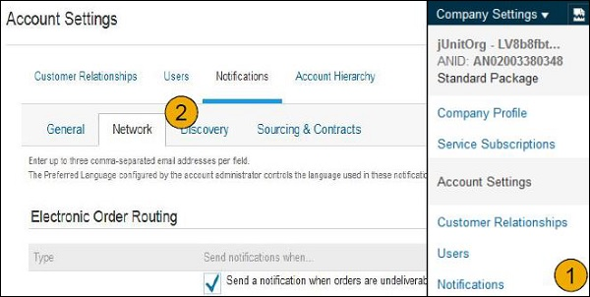

You can enter three email addresses for each notification and these should be separated with a comma. As mentioned, preferred language configured by Administrator controls the language used in sending notifications.

### Managing Electronic Order Routing

You can manage electronic order routing by using Network Settings option →Electronic Order Routing. You can select from the following methods to transact business with your customers −

* Email
* Online
* cXML
* EDI
* Fax

### Online Routing

Using this option, you can send PO to Ariba inbox without sending extra copies elsewhere.

### Email Order Routing

You have the option to include document in email message by selecting check box; this will further send a complete copy of PO in email.

### EDI Routing

The ERP system can be configured with Ariba solution and the PO can be sent via EDI.

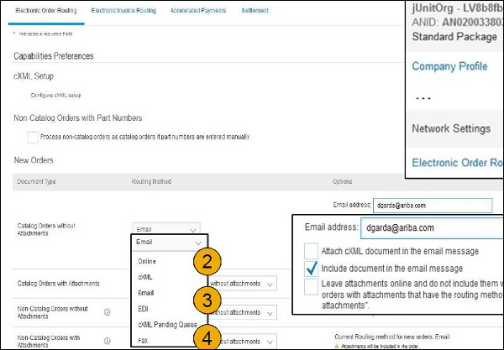

## Managing Electronic Invoice Routing

There are different ways you can also manage electronic invoice routing. To set preferences −

* Go to Electronic Invoice Routing
* You can select from one of the following routing methods − Online, cXML, and EDI. You can also set email notification for invoice routing.
* With Tax Invoicing option, you can also enter Tax ID, VAT ID and other tax related supporting data.

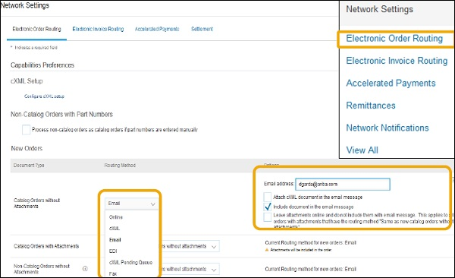

You can use Invoice Archival option to specify frequency of zipped invoice archives. Goto Tax Invoicing and Archiving tab → Invoice Archival → Configure Invoice Archival. You can select from the following frequency −

* Twice Daily
* Daily
* Weekly
* Biweekly
* Monthly

You can also select the Archive Immediately option to archive invoices in zip format immediately.

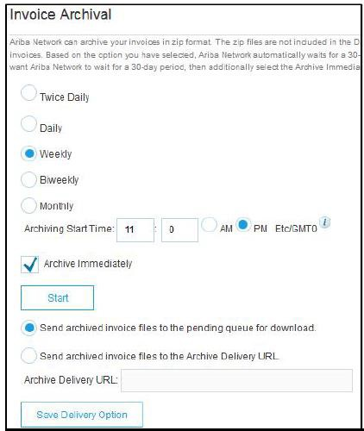

# SAP Ariba - User and Role Management

# In SAP Ariba, administrators and users perform different roles. Administrators of Ariba system perform the following responsibilities −

* Account configuration and management – registering new accounts in SAP Ariba network.
* Handle account login issues and act as primary contact for Ariba users.
* Creating new roles in Ariba system.
* Linked to user name and login entered during registration.

A user has the following primary tasks in Ariba system −

* Users can have different roles concerning procurement and supply chain process.
* Users can update their profile in Ariba system.
* Configuring notifications and workflows based on roles and responsibilities.

## Creating Users and Roles

Administrator’s primary task is to create new users and roles in Ariba system.

* To create new user and role, navigate to Account Settings → User tab. This will open Users page.
* To create new role, under Manage User Roles → Create Role button.

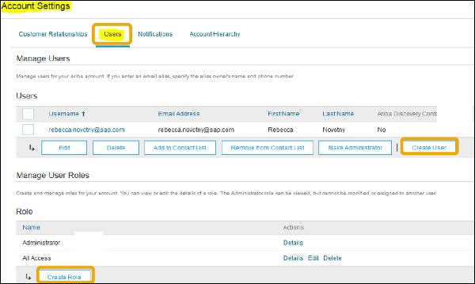

* Enter the name of role and description for the role to be created.
* Now, add permissions to role that is based user job responsibilities.
* To save new role, click Save. You can also check detail of an existing role, edit or delete a Role.

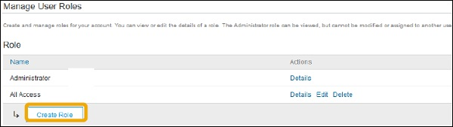

* To create new User, click **Create User** button and mention the details about user including name and contact. Next is to select a role for new user based on roles and click **Done**.

## Managing User Accounts

You can also manage existing user accounts. Select an existing user under User tab and to make changes, click Edit. To make a user an administrator, click Make Administrator option.

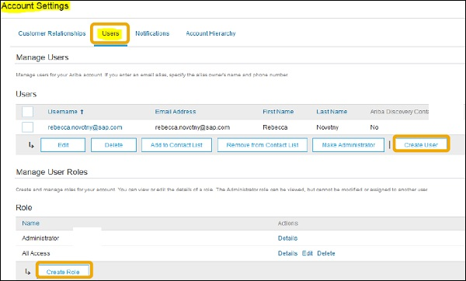

# SAP Ariba - Supplier Membership Fees

SAP Ariba provides different plans based on the number of transactions allowed under each plan. There are also customized plans based on your business needs.

Following are some common Ariba plans −

* Select
* Premier
* Enterprise
* Enterprise Plus Plan Monthly Price Transaction Volume Threshold

|  |  |  |
| --- | --- | --- |
| **Plan** | **Monthly Price** | **Transaction Volume Threshold** |
| Select | $ 50 | $50,000 to less than $250,000 |
| Premier | $ 495 | $250,000 to less than $1,000,000 |
| Enterprise | $ 2495 | $1,000,000 to less than $10,000,000 |
| Enterprise Plus | $ 7495 | $10,000,000 or more |

You can use SAP Ariba at no cost, if you transact five or less documents − POs, invoices, service entry sheets, etc. or your transaction volume should be less than the below threshold for one customer annually.

The below table shows the number of chargeable transactions for each currency annually −

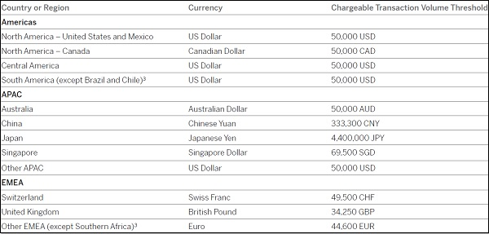

When you cross the document and transaction threshold limit for one customer as mentioned above annually, suppliers are enrolled to paid subscription and need to pay fee based on the number of transactions listed in the above table.

## The Various Fee Types

In this section, we will learn about the various fee types.

### Transaction fees

This fee is based on the financial volume you transact annually with all customers through Ariba Network.

### Subscription fees

This fee is based on the number of documents you transact annually with all customers, as well as your technology usage.

In order to help customers with high number of annual transactions, Ariba has set up an annual cap of maximum limit of **transaction fees** as shown in the table below −

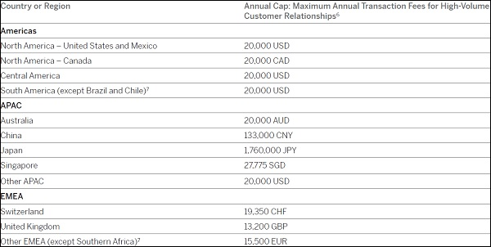

Subscription fee is based on the number of documents you processed annually. The fee also includes technology usage. Ariba offers four paid subscriptions and each subscription is based on the number of documents that can be transacted annually based on currency. There are four subscription plans −

* Bronze
* Silver
* Gold
* Platinum

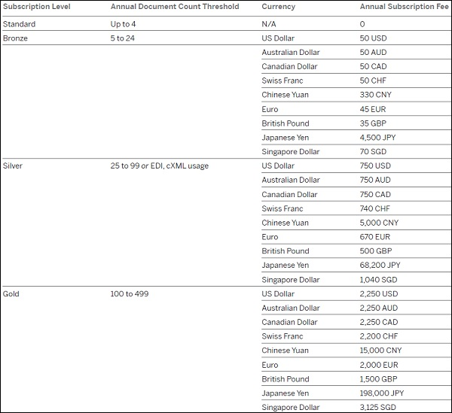

## Ariba Network Billing

## When you cross the document and transaction volume chargeable thresholds, SAP will charge either quarterly or annually based on selection, depending on when you first crossed the thresholds. If you are a new supplier, you will be billed quarterly, and it will be in advance for your next quarterly or annual period on the basis of your Ariba Network usage during your prior billing period.

### Paying your bill

You can pay your bill by going to − <https://service.ariba.com/Supplier.aw>

* Log in to your account with your ID and password.
* Find your company name in the top right corner and click on it.
* Click on Service Subscriptions.
* Click the **Billing** tab to view your invoice(s).
* Find the invoice you want to pay and click **Pay Invoice**.
* Select your payment method (credit card, check, or electronic settlement) and click **Next**.
* Enter your credit card information, if applicable.
* Confirm your subscription package, if applicable.
* If paying by cheque or electronic settlement, download your invoice and submit to your disbursement process for payment.

## SAP SRM (Supplier Relationship Management)

**SAP SRM** is a SAP product that facilitates the procurement of goods via a web-based platform. Organizations can procure all type of products like direct and indirect material, services and this can be integrated with SAP ERP modules and other non-SAP backend systems for accounting and planning.

SAP SRM allows you to optimize your procurement process to work effectively with suppliers to get long term benefits and also to perform forecasting, procurement cycle and to work with partners. You can reduce the time span and costing of procurement cycle using innovative methods to manage business processes with key suppliers.

SAP SRM supports the full procurement cycle, i.e., starting from source and purchase to pay through complete procurement process with suppliers and effectively managing supplier to build long-term relationship.

SAP SRM helps you to emphasize supplier performance management, streamline the procurement operations, put compliance with contracts and purchasing policies, and improve overall cost management and expenditure.

The future of SAP SRM is SAP S/4 HANA and SAP Ariba system for exceptional procurement and vendor management capabilities. When you have SAP S/4 HANA implemented, you can easily extend your procurement solution from on-premise solution to cloud and it allows to exchange information, improve visibility with great efficiency and effectiveness with your suppliers.

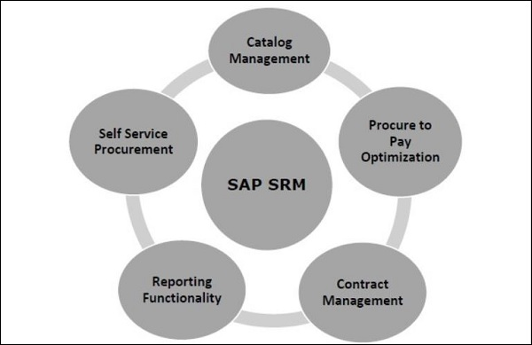

## Comparison Scorecard

|  |  |  |
| --- | --- | --- |
| **KPIs** | **SAP Ariba** | **ServiceNow** |
| Integration with SAP S/4HANA system | SAP Ariba can be easily integrated without the use of any middleware or SAP PI/HCI can be used for integration purpose. | Need 3rd party plugins/ middleware to integrate. Not standard integration and need some expertise to expose Web Services for integration or JCo option for integration. |
| Primary Functionality | Ariba is a cloud-based solution for sourcing, contracts, spend visibility, procurement and Ariba Network. | ServiceNow is basically a ticketing tool used to manage Technology Service Management tasks. It provides a centralized service catalog for personnel to request for technology services or information about applications and processes that are being used in the system. |
| Meeting Vendor Management KPI’s | With use of preconfigured workflows based on best practices, easy to automate approval processes for invoice management, procure to pay workflows, etc. | The ServiceNow system can automatically generate an approval request to individuals or groups when specific criteria are met; however, customization of approval process depends on vendor management data. |
| Other Benefits | 1. Ariba offers an end-to-end automated system that removes complexity and allows buyers and suppliers to manage everything from contracts to payments all in one place.  2. Ariba Network is one of the key components, which provides a cloud-based B2B marketplace where buyers and suppliers can find each other and do business on a single platform. | Already in place and can be used for ticket management. |
| Costing | SAP Ariba has four pricing plans — Select, Premier, Enterprise, and Enterprise Plus. The plans cost $50, $495, $2,495, and $7,495 per month, respectively. To get quotation, you can also reach- [**https://www.ariba.com/support/customer-hub**](https://www.ariba.com/support/customer-hub) | Service Now cost depends on required version. |
| Reporting | With use of custom and compound reports in Ariba, it is much more advanced as compared to standard reporting in an ERP system. Following report types are supported in Ariba system −   * Prepackaged Reports * Investigate Data * Custom Reports * Multi-fact Reports * Exporting Reports * Compound Reports | Vendor management reports depend on vendor management data. Limited reporting functionality as compared to Ariba reporting feature. |

# **SAP Ariba - Solution Areas**

In SAP Ariba cloud solution, following solution areas are covered −

* SAP Ariba Supplier Management − It manages supplier information, lifecycle, performance, and risk all in one place and can be accessed from anywhere.
* SAP Ariba Strategic Sourcing − It manages sourcing, contracting, and spend analysis processes for all types of spend – direct materials, indirect materials, and services.
* SAP Ariba Solutions for Direct Spend − Helps to connect the people, partners, processes, and information needed to manage all design-to-deliver activities.
* SAP Ariba Procurement − Helps in achieving compliance, visibility, and control while cutting costs and risks.
* SAP Ariba Financial Supply Chain − This closes the source-to-settle loop by boosting free cash flow, freeing up working capital, and delivering more bottom-line value.

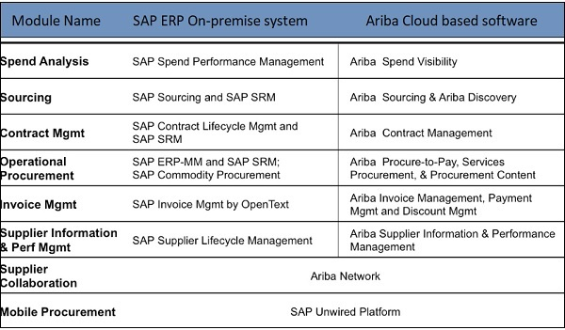

# **SAP Ariba - Configurable Workflows**

SAP Ariba modules provide easy to use workflow designs that do not need customization by technical experts. It provides preconfigured workflows based on best practices that you can use right way. With the use of drag-drop functionalities, you can easily modify rules and with the use of workflow builder, users can easily build, test and deploy workflows.

<https://www.ariba.com/solutions/solutions-overview/financial-supply-chain/invoice-management>

There are different configuration workflows that can be used.

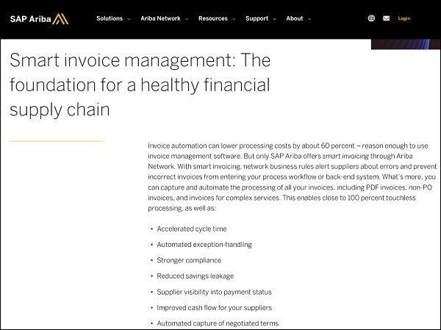

From the same link, you can check other existing configurable workflows in Ariba solution −

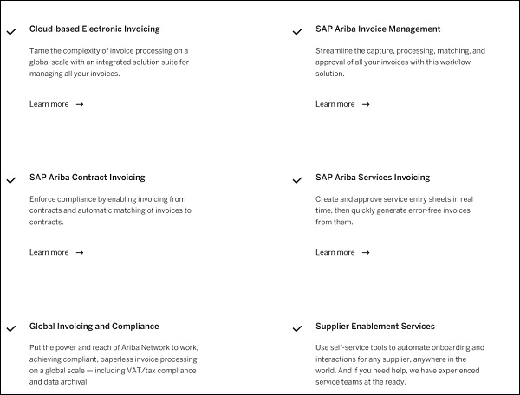

# SAP Ariba - Reporting Options

# In this chapter, we will see the Report Types supported in the Ariba system −

* Prepackaged Reports
* Investigate Data
* Custom Reports
* Multi-fact Reports
* Exporting Reports
* Compound Reports

Apart from this, if you are using SAP S/4 HANA system, it also provides different standard reports w.r.t. Procurement system.

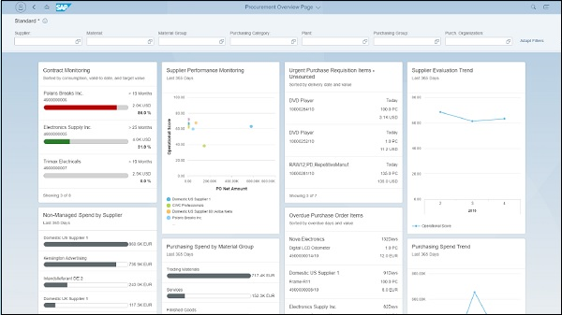

There are various dashboards’ views under each Ariba module that can be customized based on the requirement and used for reporting purpose.

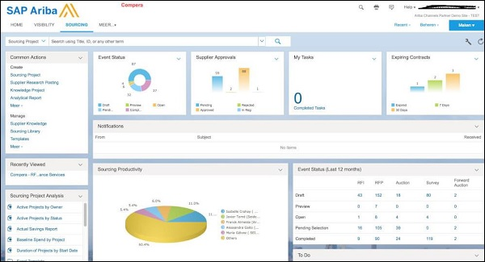

In SAP Ariba, users can also modify CSV files that pull report data, to specify report properties or permissions. Report properties can be changed using the below integration events −

* **ReportQueryPull Integration Event** − This is used to Query API queries associated with each report.
* **ReportMetaPull Integration Event** − This event is used to define report visualization and appearance of each report in Ariba system.
* **ReportPermissionMap.csv File** − This defines list of reports in Ariba system and it contains one line for each report.
* **ReportColumnMeta.csv File** − This is used to define column name in each report.

# **SAP Ariba - Integration with S/4 HANA**

SAP S/4 HANA integration with the Ariba Network is native to SAP S/4HANA and this can be performed as part of SAP S/4HANA with guided configuration. You can navigate to “Ariba account settings” and it doesn’t require use of middleware. To meet your organization policies, you can integrate using a middleware like SAP Process Orchestration PI/PO on-premise or SAP HANA Cloud Integration HCI in the cloud. SAP also provides best practices to show you which mediated connectivity alternatives should be used for integration.

With the integration of SAP S/4HANA and Ariba, cloud allows the following processes −

* Purchase order collaboration
* Invoice collaboration
* Service procurement
* Discount management
* Payment

## The Ways of Connecting SAP S/4 HANA With The Ariba Network

There are three ways of connecting SAP S/4HANA with the Ariba Network −

### Direct connectivity

You establish a system connection between SAP S/4HANA and the Ariba Network without using middleware. Under Ariba account settings, you have direct connectivity option.

### Mediated connectivity using HCI

You establish a system connection using SAP HANA Cloud Integration between SAP S/4HANA and the Ariba Network.

### Mediated connectivity using PI

You establish a system connection using middleware between SAP S/4HANA and the Ariba Network.

The SAP Process Integration design packages (TPZ files) are available on this link [https://connect.ariba.com](https://connect.ariba.com/) in a ZIP file. You must download the ZIP file and extract the files for your required version.

You can also refer to SAP Note 1991088 to know more about integration.

# **SAP Ariba - Best Practices For Integration**

For integration between SAP S/4 HANA and Ariba Network, you should use SAP Activate and best practices. To check best practices, open URL − <https://rapid.sap.com/bp/>

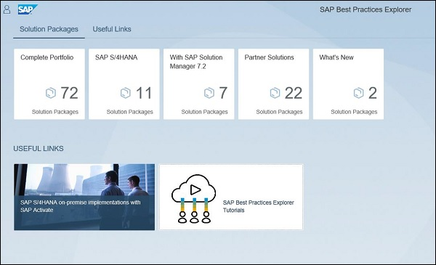

Navigate to SAP S/4HANA → Integration → SAP Best Practices for SAP S/4HANA integration with Ariba Solutions

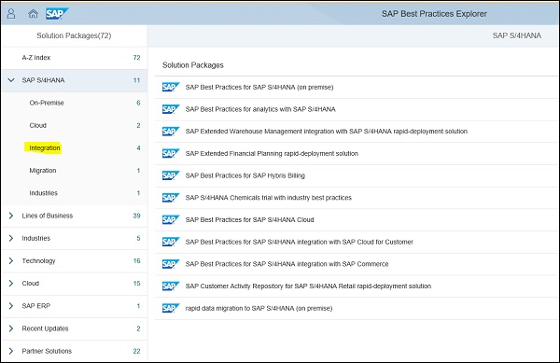

Following is the link of SAP best practices explorer to learn SAP Ariba network integration with S/4 HANA for different scope items −

<https://rapid.sap.com/bp/#/browse/search?q=Ariba&from=0&size=50>

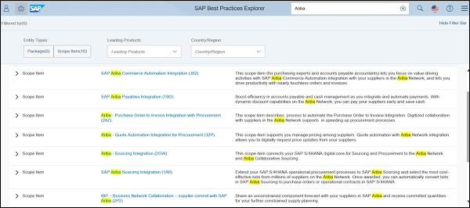

To open any of the best practices, you can click on any link and it will show business benefits and process flow under that best practice.

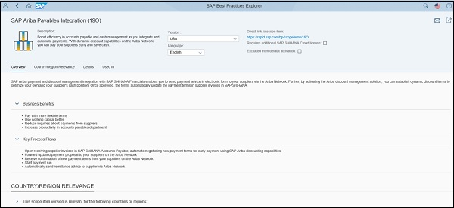

Coupa:

**Coupa: A Leading Cloud-Based Spend Management Platform**

Coupa is a prominent cloud-based spend management platform designed to help businesses optimize their procurement processes, streamline vendor relationships, and ultimately achieve greater efficiency and cost savings. Here's a breakdown of Coupa's key features and functionalities:

**Core Capabilities:**

* Procurement: Automate and streamline the entire procurement cycle, from requisitioning and sourcing to purchase order management and invoice processing.
* Vendor Management: Manage vendor relationships effectively, including onboarding, performance monitoring, risk assessment, and compliance tracking.
* Spend Analytics: Gain valuable insights into your spending patterns, identify potential cost savings opportunities, and optimize budget allocation.
* Compliance: Ensure adherence to internal policies, regulations, and contractual obligations across the procurement process.
* Collaboration: Foster seamless communication and collaboration between internal stakeholders and external vendors.

**Key Benefits:**

* Reduced Costs: Coupa helps businesses achieve significant cost savings through automation, competitive bidding, and improved visibility into spending patterns.
* Enhanced Efficiency: Automated workflows and centralized data management streamline processes, freeing up valuable time and resources.
* Improved Visibility: Gain real-time insights into your entire spending, identify trends, and make data-driven decisions.
* Reduced Risk: Mitigate risks associated with vendor performance, compliance, and fraud through comprehensive risk management tools.
* Increased Agility: Respond quickly to changing market demands and adapt procurement strategies with greater flexibility.

**Additional Highlights:**

* Open Ecosystem: Coupa integrates seamlessly with various third-party applications and platforms, extending its capabilities and enhancing user experience.
* Mobile Accessibility: Access Coupa functionalities anytime, anywhere, through dedicated mobile apps for iOS and Android devices.
* Scalable Solution: Coupa caters to businesses of all sizes, offering flexible deployment options and scalability to accommodate growth.
* Global Reach: Supports diverse business needs with multi-language capabilities, multi-currency support, and compliance with international regulations.

**Source to Pay – Flow Chart:**

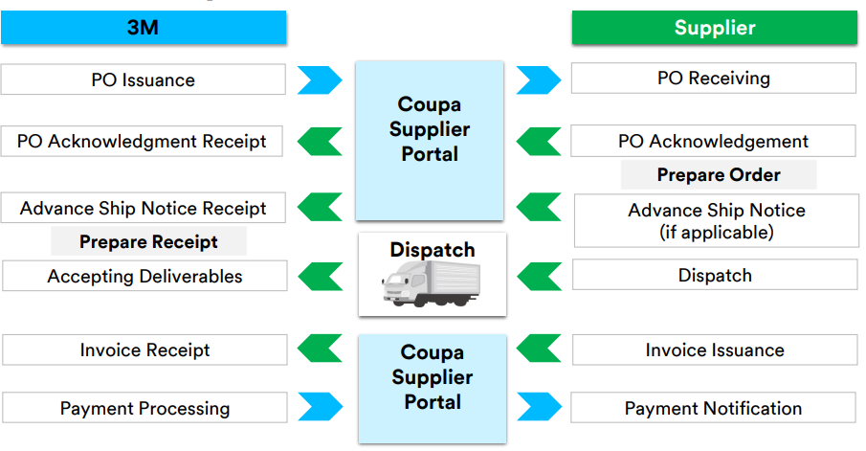

**Coupa Supplier Portal - Registration process & inviting further users:**

Step 1 – Register on Coupa Supplier Portal:

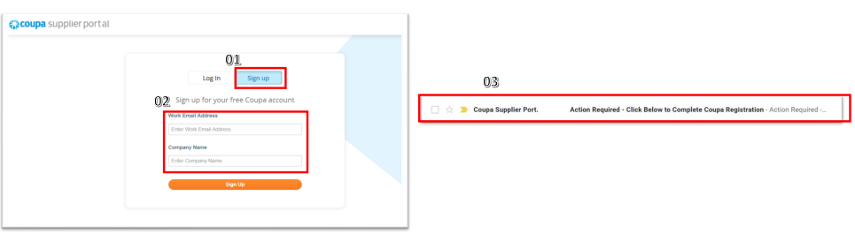

01. Open Coupa Supplier Portal Link - https://supplier.coupahost.com/. Click on the Sign-up tab

02. Input the required fields i.e., Email Address and Company Name

• Note: Suppliers should use their primary contact email address to register All PO’s created will be sent to this email address and visible on the CSP account

• The primary contact email address will become the ADMIN & have full access to all CSP functions, including user administration (inviting more users to use CSP with different permissions)

03. Once registered, the supplier will receive an email from Coupa Supplier Portal

• Note: If you have registered and haven’t received an email from Coupa, please check your Spam or Junk items folder

Step 2 – Confirm email sent to registered mail ID:

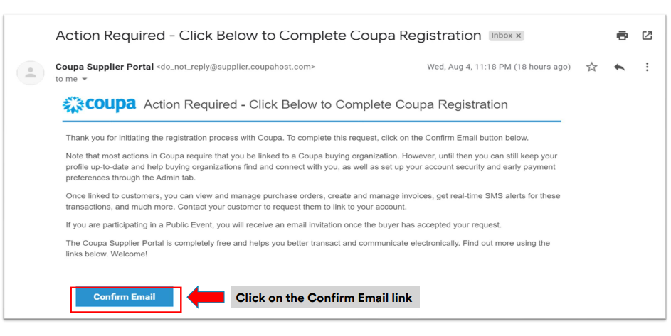

Step 3 – Input Mandatory Information & Create Password:

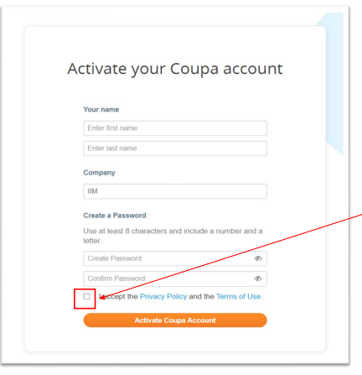

**Note:** This becomes the default admin account for your company. Once set up, you can add users and assign them roles, including account administration

Step 4 – Log-in to CSP with email ID and password:

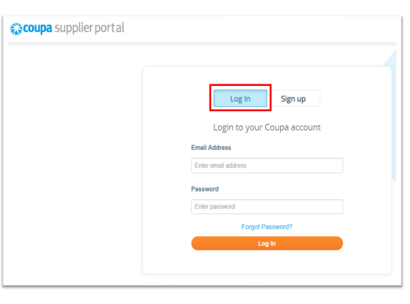

• Coupa Supplier Portal Link: <https://supplier.Coupahost.com/>

• Enter your Registered Email Address and Password created in the previous step

• Click on the Log-In tab

Step 5 – Two-Factor Authentication:

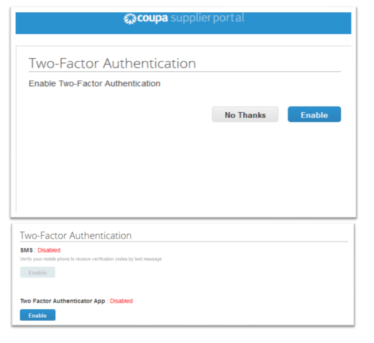

* During your first log-in, the User will be prompted to enable Two-Factor Authentication (2FA)
* You may click the “Enable” tab, for additional security control on your account OR
* You may click “No Thanks” if you wish not to enable 2FA
* 2FA is a security system that requires two distinct forms of identification, to access something
* It strengthens your Coupa Account security, by asking 2 types of information from the user — Password AND Personal Identification Number (PIN) or Code generated from Google Authenticator Application
* For more information, see the link : Enable or Disable Two-Factor Authentication

Step 6：Linking Coupa Account (CSP) with 3M:

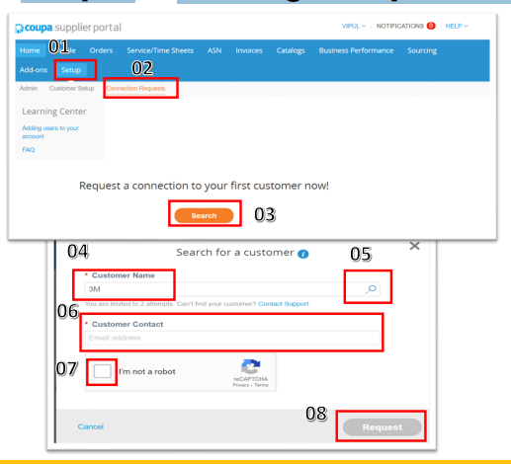

1. Click on Setup
2. Click on Connection Request
3. Click on Search
4. Write “3M” in the Customer Name field.
5. Click on the “Search” icon
6. Enter below in the Customer Contact Field (depending on the Country); STPeCommerceSG@mmm.com

STPeCommerceMY@mmm.com

STPeCommerceVN@mmm.com

1. Tick Checkbox “I’m not a robot” 08. Click on the “Request” tab.

Inviting Additional Users on CSP:

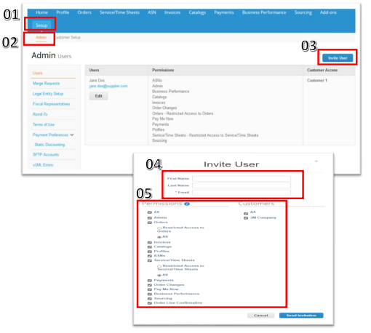

Supplier Admin can manage ”User Permissions” and “Customer Access” by assigning certain users to only certain customers, limiting documents access and the functions they can perform basis assigned customers. Steps:

1. Click on Setup
2. Click on Admin
3. Click on Invite Users
4. Enter First Name, Last Name & User email address
5. Click the checkbox to control the permissions & access

For more information, see the link: Manage Users - Coupa Success Portal

**Create Public Profile & Setup Legal Entity:**

Create your Public Profile (Optional):

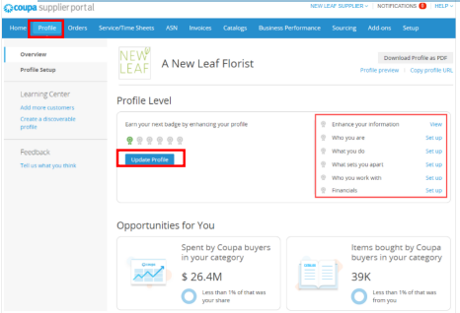

* In CSP, you have a Public Profile that is visible in the CSP Directory and allows potential customers to find your profile
* Having a complete profile provides customers with relevant information to do business with your organization
* Better the profile, better are the chances of landing new customers

For more information, see the link :

Create Your Public Profile - Coupa Success Portal View and Update Your Public Profile - Coupa Success Portal

* A summary of the Profile information is seen on the Homepage
* The top section displays Profile Completeness (indicated by filled in badges under Profile Progress) and when the profile was last updated
* You can click ”Improve Your Profile” to open your profile

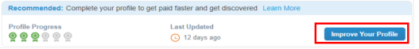

Legal Entity Setup (Mandatory-3M Singapore/Malaysia):

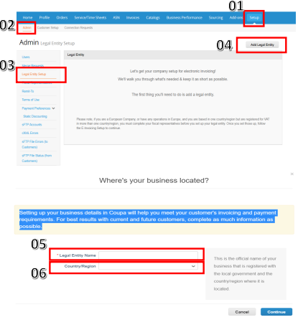

* Legal Entity is the official name of your business registered with the local government (legal entity name)
* Setting up your business details in Coupa will help you meet your customer’s Invoicing needs
* Complete as much information as possible

**Steps:**

1. Click on Setup
2. Click on Admin
3. Click on the Legal Entity Setup tab
4. Click on Add Legal Entity tab
5. Enter your Legal Entity Name – Official Name of your business
6. Country/Region – a Registered country of your legal entity

Legal Entity Setup (Mandatory-3M Singapore/Malaysia):

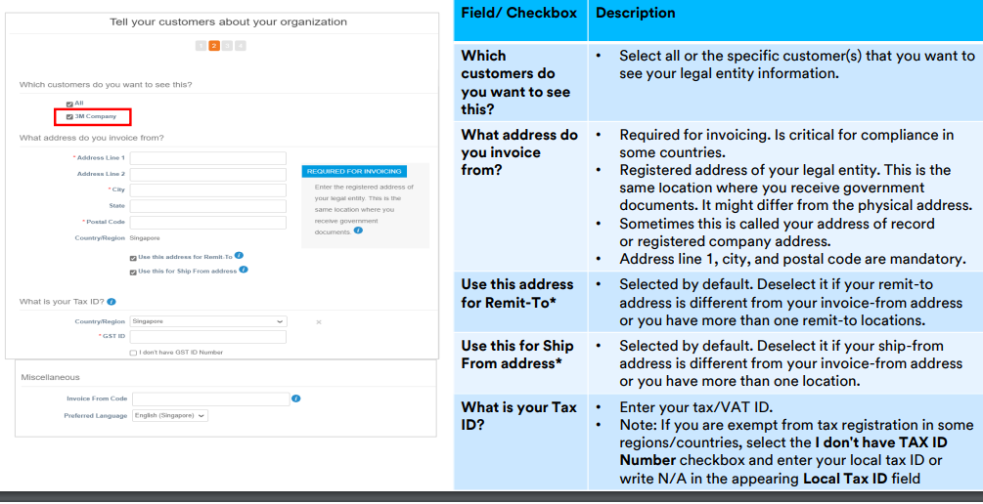

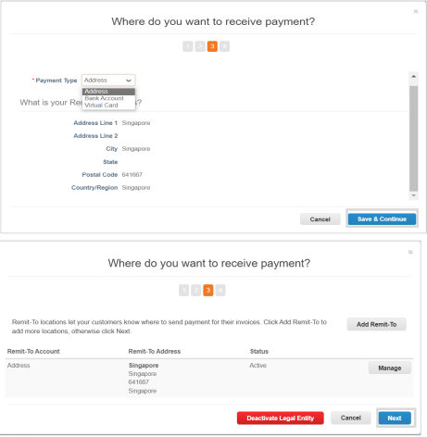

* Mentioned 2 sections are not relevant for 3M
* Invoices will be paid only to the Bank Accounts provided to 3M irrespective of the information provided here
* To change/update your bank account details, please contact 3M representative
* Click Next to add the address where you want to ship goods from

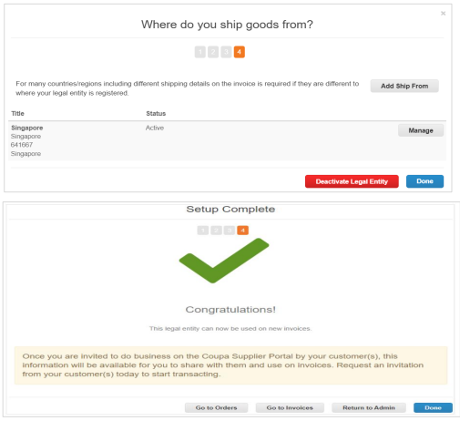

* Click “Add Ship From” location if Ship From is different than your Invoice From address
* Fill in the mandatory fields and click ”Continue”
* After completing the legal entity setup by clicking ”Done” (i.e: after adding a legal entity), you may use it on new invoices
* From the Setup Complete page, you can choose to Go to Orders, Go to Invoices, or Return to Admin page

For more information, see the link : Set up Legal Entities - Coupa Success Portal.

Manage Legal Entity-Add 3M after Linkage Request is approved:

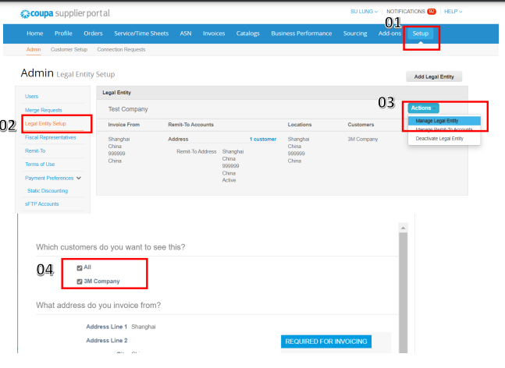

In case, Supplier do not find “3M” customer on legal entity.

Follow below steps to add Customer “3M” after your linkage request is approved.

Steps:

1. Click on Setup
2. Click on the Legal Entity Setup tab
3. Click on Manage Legal Entity tab
4. Click on “3M Customer” checkbox on Page 2

**Coupa Home Page Overview**

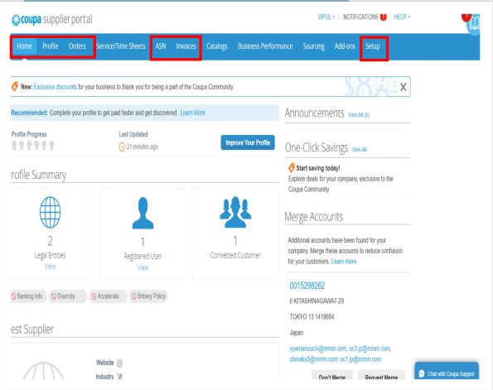

**Home:** View and improve the public profile and see the list of connected company

**Profile:** Create and manage your profile, including addresses and contacts.

**Orders:** View and access the purchase orders you received from different customers.

**ASN:** Create Advance Ship Notice

**Invoices:** Create and manage invoices

**Setup:** Manage users, legal entity, merge requests, etc.

**Note:** 3M is not using the below tabs for now:

• Service/Time Sheets, Catalogs, Business Performance, Sourcing and Add-Ons

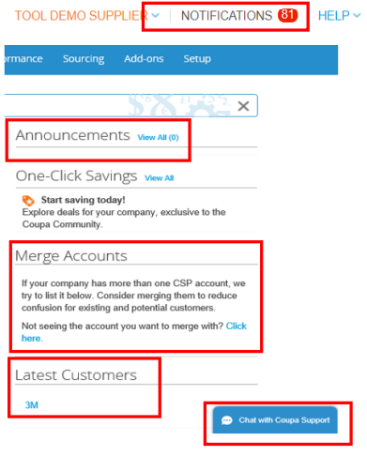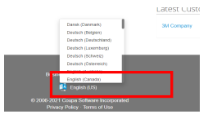

* **Settings & Notification:** Using this, the Account settings can be managed. and Notifications viewed and customized
* **Announcements:** View 3M Announcements to suppliers here
* **Merge Accounts:** If a company has more than one CSP account, they can be merged to reduce confusion for existing potential customers
* **Latest Customers:** Shows the latest customer added by the supplier account
* **Chat With Coupa Support:** Connect with the Coupa support team to resolve any technical issues
* **Change Language:** Select the preferred language for CSP.

**Purchase Orders**

* View 3M Purchase Order (PO)
* Purchase Order Acknowledgement (POA)
* Purchase Order (PO) Change Request

**View 3M PO & Acknowledge–From Email (using SAN):**

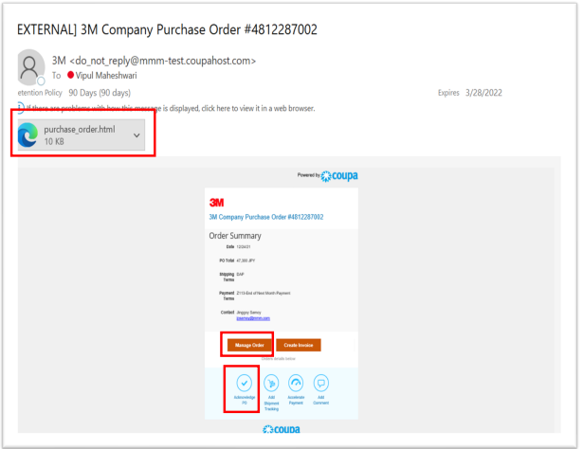

• **Supplier will receive an email notification** whenever a PO is sent to their Primary Email registered with 3M & the CSP Account Users

• **Manage Order:** Click on the button to get an electronic view of the PO

• **PO Print will be attached to the email in HTML** format which can be viewed, saved, and printed

• **Acknowledge PO:** Click on the tab to acknowledge the PO directly from the email.

**Note:**

• PO details should be checked for accuracy. Ex: Item description, Price, Ship to Address, Delivery Dates etc.

• After reviewing & if accurate - Click on the Acknowledge PO tab.

**View 3M Purchase Orders – From CSP:**

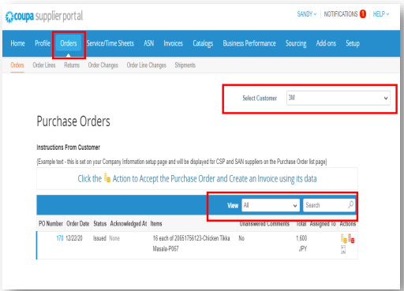

To view a 3M Purchase Order in CSP:

1. Login to CSP

2. Click on the Orders tab on the CSP homepage. The Purchase Orders page would appear

3. Select 3M from the Select Customer drop-down list in the top right corner

4. Filter the table by columns, use the search bar to find a specific PO OR Click on the View drop-down list to select a filter on applicable orders

5. For more details on a specific PO, click on the PO Number hyperlink to open the PO details.

View 3M Purchase Order Lines:

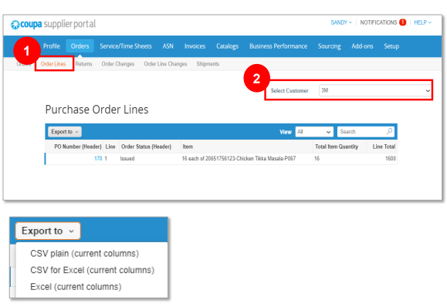

**Steps:**

1. Click on the Order Lines tab to see PO Line details

2. Select “3M” from the Select Customer drop-down list.

**Note:** You can export the PO or PO Lines table in CSV or Excel format by clicking on Export to

**Purchase Details:**

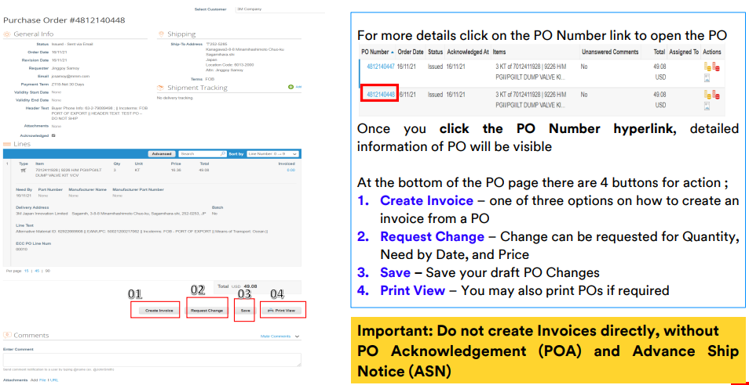

**PO Acknowledgement – From CSP**

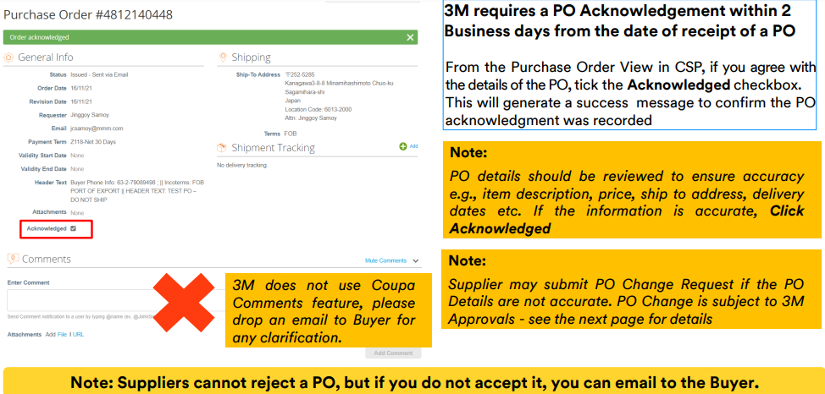

**Request a Purchase Order Change:**

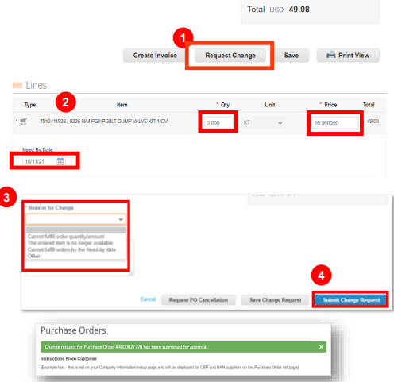

You may request a PO change if you are unable to deliver the products by the Need by Date, or the order details are incorrect

To begin, the Supplier must log in to CSP Account. PO Change cannot be submitted via the email notifications button.

**Steps:**

1. Click Request Change on the PO details page

2. Edit the fields that are enabled for change, such as Quantity, Price and Need By Date

**Note:** Suppliers cannot reduce the quantity/amount below the values already received or invoiced against

3. Select a Reason for Change from the drop-down list

4. Click on the Submit Change Request Button

**Note:** If “Other,” you also need to provide a comment The PO change will go through an Approval Process which can either be Approved or Rejected by the buyer.

**View PO Revision Details**

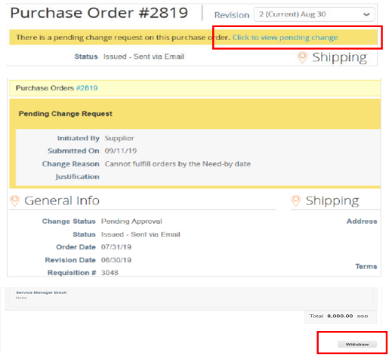

• Changes are effective, post change request approval

• When a PO change request is Approved or Rejected, Suppliers will receive the Order change request - Approved or Rejected Notification.

• After submitting a PO Change request & awaiting 3M’s approval, you may view the Pending Changes tab

• Click to view pending change at the top of the PO

• You may also select a PO revision to view, by clicking the drop-down list next to the PO number

• Pending Change Request page shows PO number, revision date, change request submission date, the reason for the change, change status, change type, etc

• Supplier can withdraw the change request by clicking Withdraw at the bottom of the page.

**Key Points–PO Acknowledgement & Change Request:**

• PO should be acknowledged within 2 Business Days if suppliers agree on all aspects of the PO

• PO Acknowledgement applies to all lines on the purchase order

• If Suppliers do not agree on the PO, Change request should be raised OR email Buyers for any clarifications, within 2 Business Days

• Supplier can modify the Quantity, Price, and Need by Date on the existing lines OR Delete the existing lines on the PO via PO Change. The addition of lines is possible only by 3M Buyers

• In case you cannot deliver the full quantity by the required Need by Date, Suppliers should email Buyers to split the PO Lines according to the new Delivery Date and acknowledge PO

• 3M does not currently use the Coupa Comments feature on transactions. In case of any concerns, please contact buyers via phone or email.

**PO Requested Delivery:**

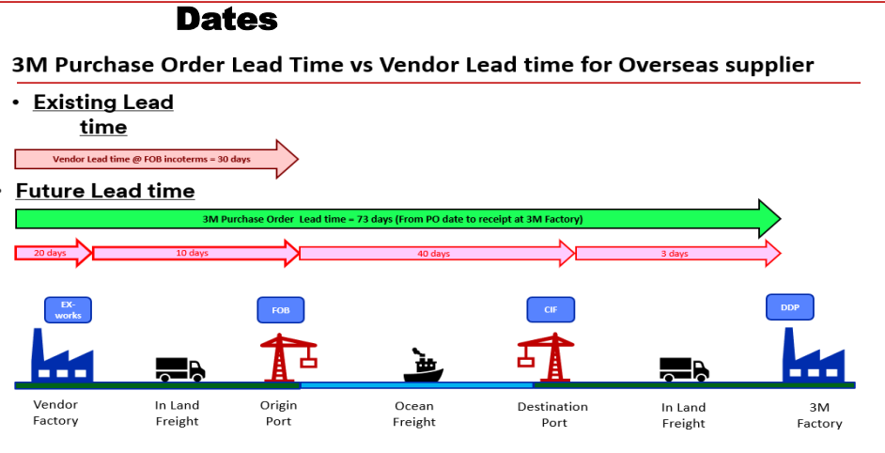

**Key Point– PO Requested Delivery Dates:**

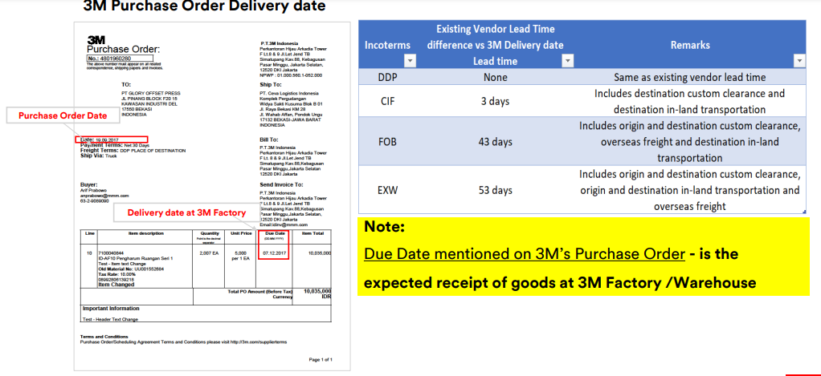

**Advance Ship Notice (ASN)**

1. **ASN creation**
2. **View and Manage ASN**
3. **ASN without Batch Managed Materials**
4. **ASN for Single Batch Managed Material**
5. **ASN for Multiple Batch Managed Materials**

Creating an Advance Ship Notice (ASN):

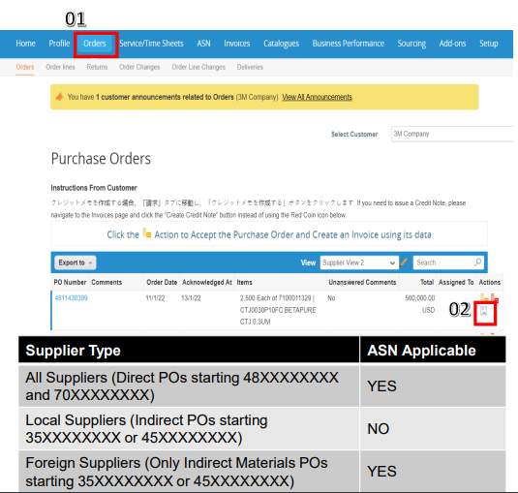

• The purpose of an ASN is to advance notify 3M of the deliveries suppliers will make

• Create an ASN when you know exactly what you are going to ship to 3M

• The 3M PO will determine when an ASN is required (Refer to below table)

• To create an ASN for the PO from CSP:

1. Navigate to the Orders tab and search for the PO where an ASN is required

2. Click the Flip to ASN icon

**Creating an Advance ship notice (ASN):**

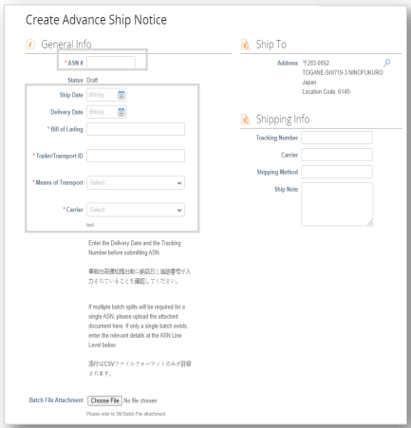

• **ASN Number:** Enter up to 10-digit alphanumeric number, not including special symbols (MANDATORY)

• **Ship Date:** Enter date when goods are shipped from location (Coupa will accept only current & next day) (OPTIONAL)

• **Delivery Date:** Enter expected delivery date at 3M Warehouse (MANDATORY)

• **Bill of Lading:** Input text “DUMMY” for domestic transactions that are not imported (MANDATORY)

• **Trailor/Transport ID:** Please enter Truck/Vehicle Number (MANDATORY). Input text “DUMMY” if not applicable

• **Mode of Transport:** Select from the drop-down list as applicable (MANDATORY)

• **Carrier:** Select from the drop-down menu. If none of the above apply, select “OTHER“ (MANDATORY).

**ASN – Non-Batch Managed Materials:**

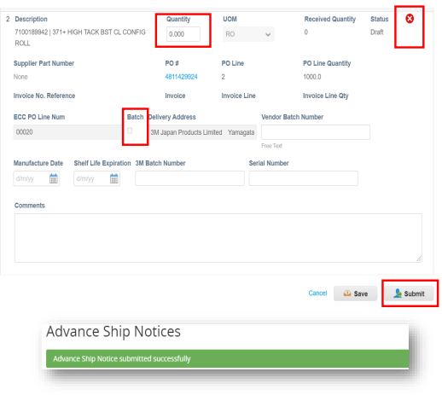

• Validate and change the Quantity, if needed, on the ASN Line Level

**– Note:** There is no need to populate the Vendor Batch Number, Manufacturer Date, Shelf-Life Expiration, 3M Batch Number, or Serial Number if Batch Check Box is not checked

• Delete the additional ASN Lines if the ASN is not applicable for that PO Line

• Scroll to the bottom of the ASN Page and click Submit

• ASN submitted successfully" message will be displayed once ASN is successfully recorded.

**ASN – Single Batch Managed Material:**

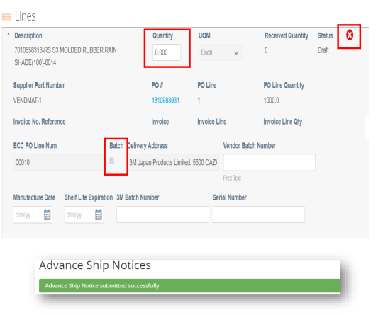

If the ASN only contains a single batch managed material, enter the details directly into the CSP ASN line screen to capture the batch details:

• Validate and change the Quantity if needed on the ASN Line Level and populate the additional fields: o Vendor Batch Number (MANDATORY) – Refer to Slide 52 for batch naming convention o Manufacture Date (MANDATORY) o Input Shelf-Life Expiration, 3M Batch Number, and Serial Number (if applicable)

• Delete the additional ASN Lines if it’s not applicable for that PO Line

• Scroll to the bottom of the ASN Page and click Submit.

**ASN – Multiple Batch Managed Materials**

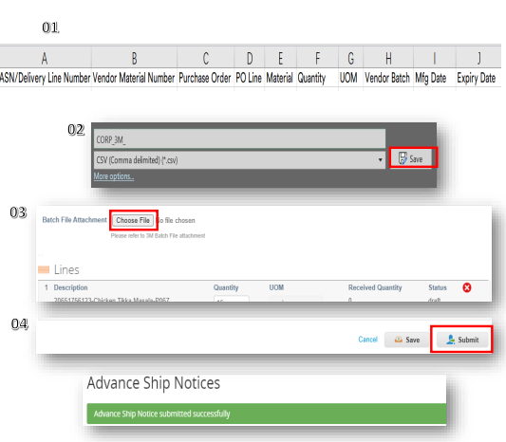

If the ASN contains multiple batch managed materials per line with multiple splits, a CSV file needs to be uploaded to capture the necessary information (“Coupa ASN Upload Template“ is available on the Supplier Direct Website)

Steps:

01. Populate the columns of the file, and follow the below logic to ensure the ASN is successfully processed by 3M:

▪ If a PO Line is split among multiple batches, create multiple records with the same PO Line number and unique Batch numbers with the appropriate Quantity

02. Save the template file in CSV format Only

03. On ASN Header Level, click Choose File and select the file

04. Scroll to the bottom of the ASN Page and click Submit

**Note:** "Advance Shipment Notice submitted successfully" message will be displayed once ASN is successfully recorded.

**ASN – Upload Template Explanation:**

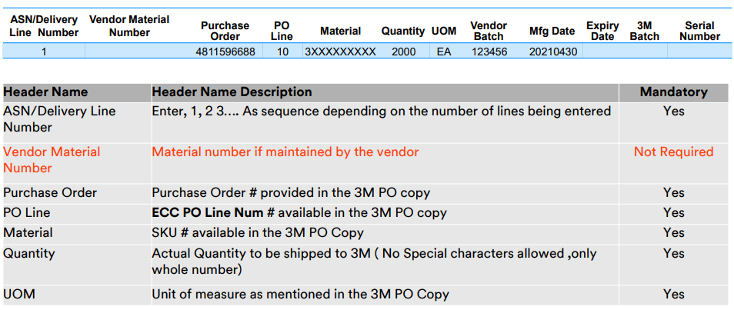

**ASN – Upload Template Explanation**

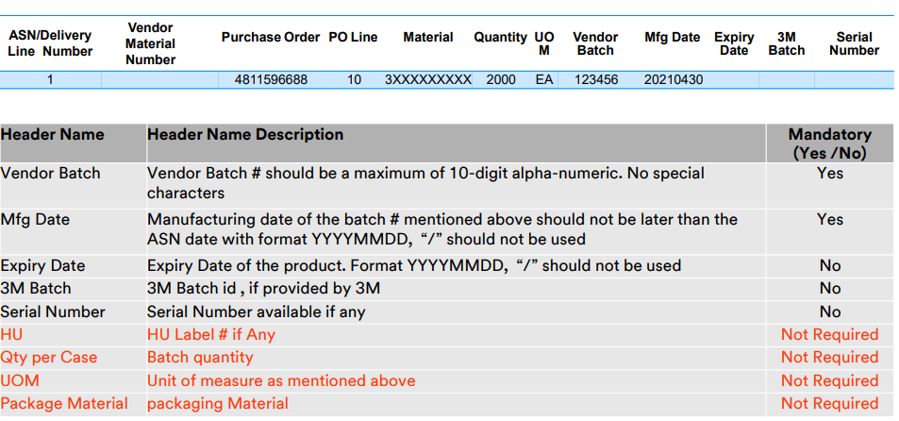

**ASN - Multiple Batch Managed Materials**

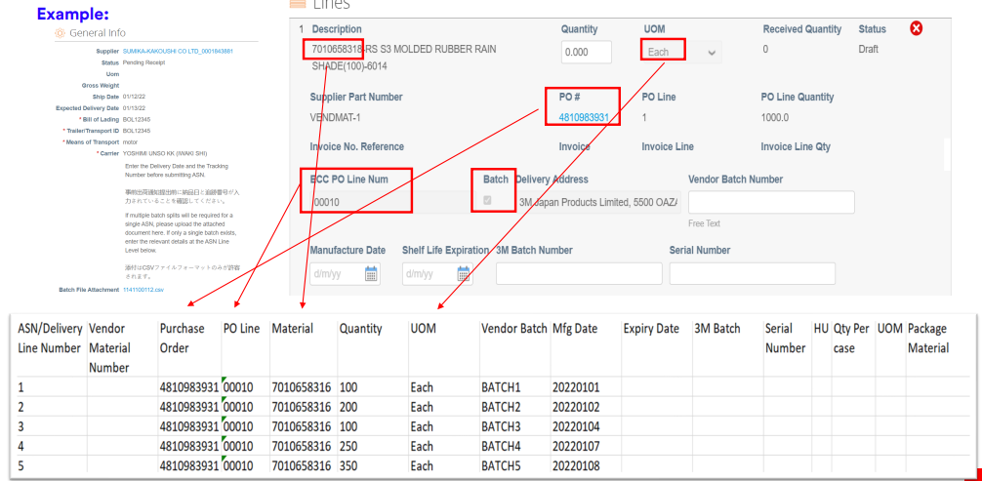

**Batch Managed – Key Points**

The Batch ID/Lot Number is created for material must:

▪ Not be greater than 10 characters

▪ Not contain spaces

▪ Only contain alphanumeric characters – A through Z and 0 through 9 only – No special characters, i.e., -, _, /, \, $, *, #, @, etc.

▪ Not start with leading zeros if entirely numeric (e.g., 09192020)

▪ Contain one (and only one) Date of Manufacture

▪ Contain no more than one Expiry Date

View/Manage PO ASN:

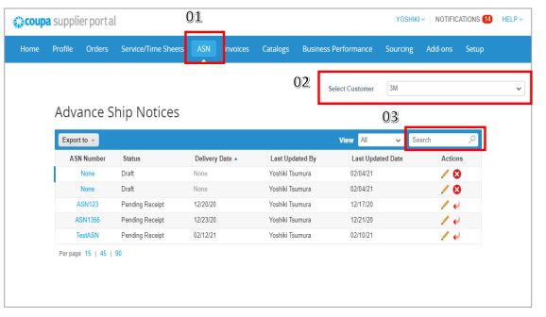

Steps:

1. Click on the ASN tab in CSP. The Advance Ship Notice page appears

2. From the Select Customer drop-down list in the top right corner, select 3M

3. You can filter the table by columns, use the search bar to filter with a search term or click on the View drop-down list to perform advanced filtering

**Note:**

• ASN Status will remain in Pending Receipt after submission. It does not mean that the Goods are not received by 3M

• Suppliers should not edit the ASN once it is submitted. In case of any correction, please email to the Buyers who will assist in canceling the OLD ASN. Supplier can thereafter submit the new ASN.

**Invoices**

Create Invoice

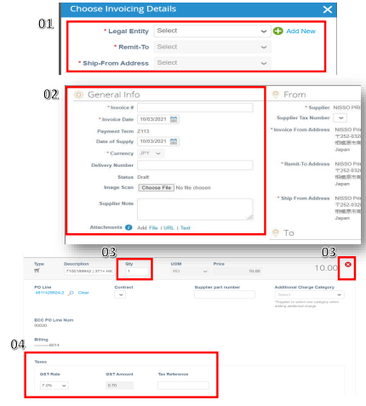

Once a PO Flip has been completed, the below key information is required to process the invoice:

01: Choose the Legal Entity, Remit To, and the Ship-From Address as we created on Slide 22.

02: Populate the mandatory General Information including:

▪ Invoice # - Enter your specific invoice number

▪ Invoice Date – Date when the invoice was created

Note- Invoice Date should not be in the future.

Note - Invoice Number should be unique and no special characters

Note- Supplier should not attach another invoice to this transaction as the Coupa generated PDF is your and 3M legal invoice. Suppliers may attach other documents e.g., Delivery Slips, Custom Slips, etc. if required)

03: Validate the Invoice Quantity at the Invoice Line level. (Note- Supplier may delete additional PO Lines if not billing)

04: Select the Tax Rates for Invoices.

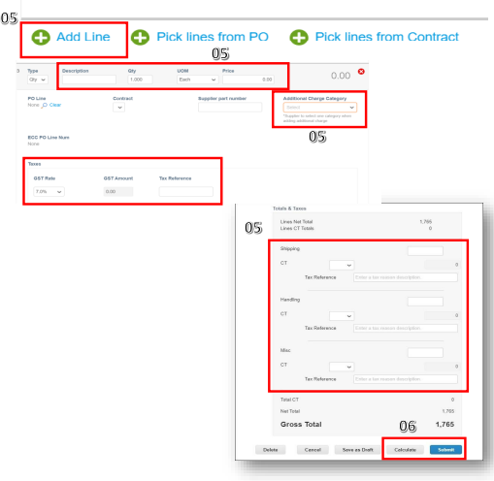

05: Supplier must add a line on the Invoice for additional charges e.g., Discount, Insurance, Assist, etc.

• Click on the Add Line Button.

• Enter Description, Qty, and Price.

• Supplier must choose “Additional Charge Category” for these additional lines.

• Choose the Tax Rate if applicable. OR enter the charges in the Summary Charges for Shipping, Handling, or Misc.

06: Scroll down to the bottom of the Invoice Page and Click Calculate and then Submit. Follow prompts to validate that you are ready to send an Invoice to proceed in submitting the invoice.

Note: - Once the Invoice is submitted, the Supplier cannot modify that Invoice.

Note: - Supplier should not email Invoice Copy to the 3M Invoice Email Address for Singapore and Malaysia only. Note – Once a PO Line is fully invoiced (Approved or Pending Approval), It cannot be invoiced again.

**View Payments:**

Coupa Supplier's will receive an email containing Payment/Remittance information.

Note: If payment method is check, email remittance will not be sent

**Invoice Status:**

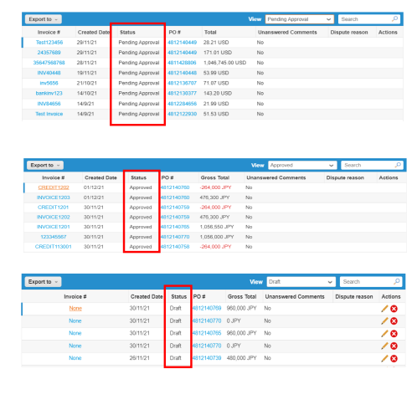

• Once an Invoice is submitted to 3M, it will be in Pending Approval Status

• The Status will change to Approved after the vendor invoice is approved and posted in the 3M system

• The Draft status implies that the supplier has only saved the invoice and it has not been submitted to 3M

**Note:** The payment will be made to supplier as per their agreed contract terms.

**Credit Notes**

* Create a Credit Note
* Resolve a Dispute by Creating New Invoice
* View Existing Credit Notes

Create Credit Note:

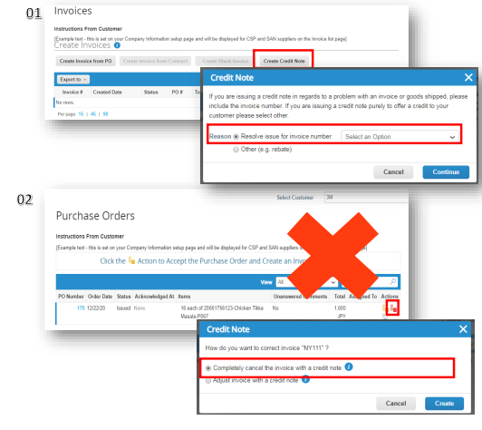

Coupa supports Credit Note functionality to perform return on an invoice. Supplier should create Credit Notes only from Invoice Screen.

01. Click on the Create Credit Note button from the Invoices page to:

▪ Resolve issue for (a specific) Invoice Number, or

▪ Choose “Other” for other credit reasons

02. Supplier should not create Credit Note from the Purchase Order Screen using Red Coin Button.

**Resolve a Dispute Invoice:**

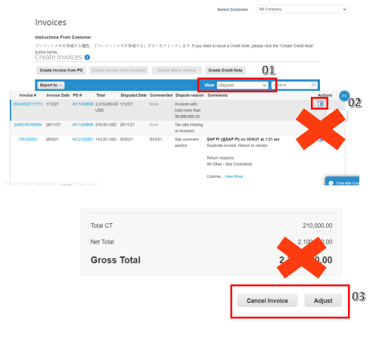

• 3M may dispute a supplier-created invoice for multiple reasons. The supplier should review the dispute invoices and the reason associated and re-create new Invoice.

• Supplier do not need to act on Disputed Invoices. Supplier can directly create a new Invoice.

**View Existing Credit Notes:**

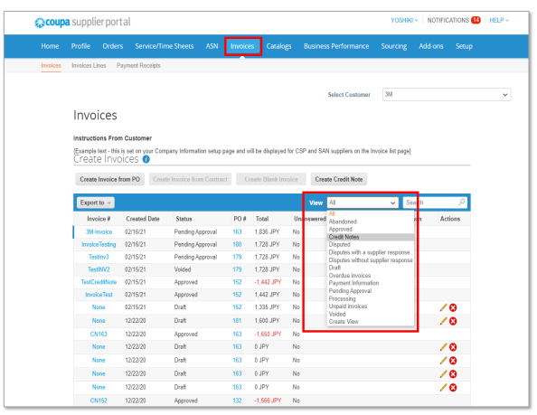

Steps:

1. Select Invoices page

2. Find View drop-down list to filter what type of columns you would like to be visible

3. In the appearing pop-up, choose Credit notes.

**Summary:**

• PO should be acknowledged within 2 Business Days if suppliers agree on all aspects of the PO

• If Suppliers do not agree on the PO, Change request should be raised OR email Buyers for any clarifications, within 2 Business Days

• 3M does not currently use the Coupa comments feature on transactions. In case of any concerns, please contact buyers via phone or email

• ASN must be submitted for Direct PO’s (starting from 48XXXXXXXX) when goods are ready for ship. Foreign Supplier must submit the ASN for Indirect Material POs too

• Carefully look at the Batch Managed Indicator on the ASN, and mandatorily provide batch number and manufacturing date information

• Supplier must attach only the .CSV file to the multi batch attachment field

• Supplier are allowed to create invoices once they ship out the goods.

• Supplier should contact buyer for any clarification.

**Learning References:**

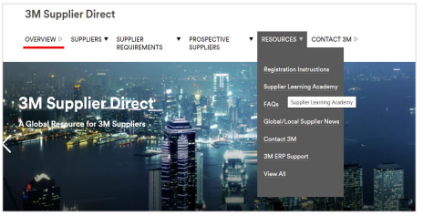

3M Learning Material is accessible @

<https://www.3m.com/3M/en_US/suppliers-direct/global-landing>.

• Choose your country based on the purchase order origin country Coupa Supplier Portal (CSP) is accessible @

<https://supplier.coupahost.com/>

Coupa Hosted Training content is available @

<https://success.coupa.com/Suppliers/For_Suppliers>.

For any eCommerce related questions, please contact:

STPeCommerceSG@mmm.com – Singapore

STPeCommerceMY@mmm.com – Malaysia

STPeCommerceVN@mmm.com – Vietnam